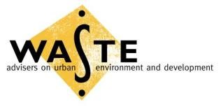

Promoting Integrated Sustainable Waste Management through Public-Private Partnerships (PPP-ISWM)

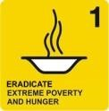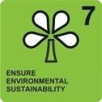

“Improving Lives and Livelihoods of Poor People in
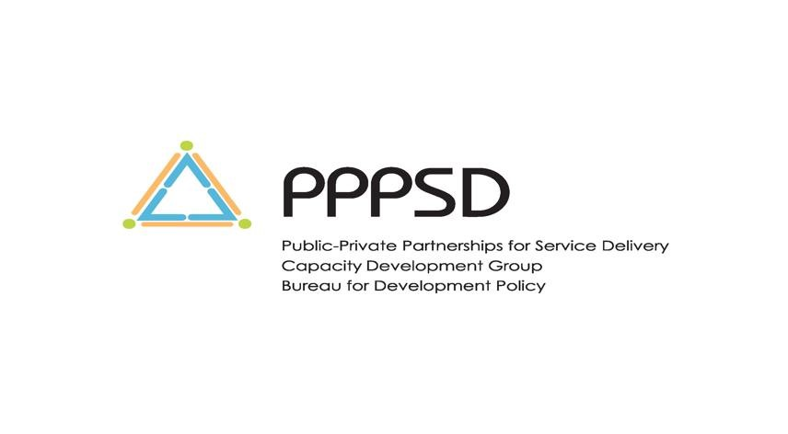
Cities and Municipalities in Low-Income Countries through Improving the Performance and Sustainability of Solid Waste Management Systems”

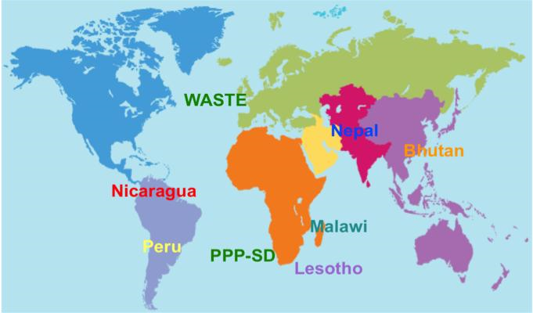

(

PPP-ISWM Training April 2010, Paro, Bhutan

The content of this Report does not necessarily reflect the views of the United Nations Development Programme, its Executive Board or its Member States or that of the other co-organisers of the event. The purpose of this report is to provide a truthful and accurate summary of the presentations and discussions of the training held in Paro, Bhutan on 26 April - 29 April 2010.

Copyright © 2010

UNDP Bureau for Development Policy (BDP), Capacity Development Group (CDG), Public-Private Partnership for Service Delivery (PPPSD) Programme, Asia & the Pacific.

UNDP Regional Centre Bangkok (RCB)
3rd Floor, UN Service Building, Rajdamnern Nok Avenue, Bangkok 10900 Thailand.
Tel.: + 66 (2) 288 2710
URL: http://regionalcentrebangkok.undp.or.th
UNDP/PPPSD: pppsd@undp.org

Acknowledgements

The meeting organisers would like to thank Hendrik Visser (Consultant), Lilliana Abarca (WASTE) and Batdelger Luuzan (Consultant) for their respective contributions to the report under the guidance of Diana Brandes – van Dorresteijn (UNDP RCB).

They also would like to thank Nabina Shrestha (UNDP Nepal), Pema Dorji (Thimphu Municipal Corporation) and Tashi Dorji (UNDP Bhutan) for their feedback and substantive inputs. Special thanks go to Ivo Haenen (WASTE), Sonam Y. Rabgye (UNDP Bhutan), Pranee Threekul (UNDP RCB) for their outstanding logistical and organisational support.

Finally, the meeting organisers would like to express their earnest appreciations to the Thimphu City Corporation for identifying participants and co-facilitating the training.

Foreword

The PPP-ISWM initiative is a 4-year programme, jointly implemented by the UNDP Public-Private Partnerships for Service Delivery (PPPSD) facility and the Dutch NGO Advisers on Urban Environment and Development of the Netherlands (WASTE). It is funded by the Government of the Netherlands through its Department of International Cooperation (DGIS) of the Ministry of Foreign Affairs.

The main objective of the programme is to stimulate effective cooperation between public, private and civil society sectors and to improve lives and livelihoods of poor people in cities and municipalities of low-income countries through improving the performance and sustainability of solid waste management systems. The programme is specifically formulated to contribute towards the achievement of the Millennium Development Goals (MDGs), notably goals 1 and 7 (targets 9, 10 and 11), through supporting multi-stakeholder PublicPrivate Partnerships (PPP) and the application of the Integrated Sustainable Waste Management (ISWM) methodology. The UNDP-PPPSD – WASTE partnership builds upon years of experience of UNDP-PPPSD in local level PPPs and WASTE in the ISWM methodology and brings together the strengths and comparative advantages of each of these partners and their respective networks of development practitioners.
PPPSD‟s strong engagement at country level with government counterparts and local actors through the UNDP Country Offices enables the initiative to have clear upstream linkages. PPPSD provides policy advisory and capacity development support in establishing enabling environment: legal, regulatory, policy and institutional framework for PPPs in basic services delivery. Its wide network of academic institutions and practitioners provides knowledge and partnership support from regional and global level.
WASTE and its partners from the Association of South and North Organisations (SURCO) provide the partnership with horizontal and downward linkages. In summary, this programme aimed at supporting PPPs itself represents such a partnership, and the learning in the field will thus be internalised within the programme itself as well.
In 2009, within the framework of the PPP-ISWM programme a pilot project was launched in Bhutan to improve delivery of municipal solid waste management services. Its aim is to create employment opportunities and reduce environmental impacts of waste and its associated risks on human health through the piloting of a Pro-Poor gender sensitive PPP model in solid waste management focused on targeted urban communities within Thimphu Municipality. The project will also support the Government of Bhutan in its formulation and institution of necessary by-laws, rules and regulations to implement the PPP related sections of its newly adopted Waste Prevention and Management Act.

The PPP approach is relatively new in Bhutan. The demand for a wider dissemination of knowledge on PPP and ISWM is strong. Therefore, the Thimphu Municipality, in coordination with UNDP Country Office in Bhutan and the PPPSD team organised a training to introduce ISWM and PPP approaches as instruments for planning and implementation of integrated waste management initiatives and to support inclusive partnerships using the strengths of all partners to address solid waste management service delivery challenges to achieve the MDGs.

Maleye Diop
PPPSD Global Task Manager
UNDP Regional Centre Eastern and Southern Africa

Diana Brandes – van Dorresteijn Lilliana Abarca
PPPSD Programme Specialist Waste, Senior Advisor
UNDP Regional Centre Asia and Pacific Gouda, the Netherlands

Acronyms

BCCI | Bhutan Chamber of Commerce and Industries
CA | Capacity Assessment
CBO | Community-Based Organisation
CD | Capacity Development
CSO | Civil Society Organisation
FBO | Faith-Based Organisation
GHN | Gross National Happiness
ISWM | Integrated Sustainable Waste Management
MDGs | Millennium Development Goals
MSW | Municipal Solid Waste
MSWM | Municipal Solid Waste Management
MWHS | Ministry of Works and Human Settlement
NGO | Non-Governmental Organisation
NSA | Non-State Actor
NSP | Non-State Provider
Nu. (also BTN) | Ngultrum
PET | Polyethylene Terephthalate
PM | Project Manager
PPt | Public Participation
PPP | Public-Private Partnership
PPP-ISWM | Public-Private Partnerships for Integrated Sustainable Waste Management
PPPSD | Public-Private Partnerships for Service Delivery
PPPUE | Public-Private Partnerships for the Urban Environment
RSPN | Royal Society for Protection of Nature
SW | Solid Waste
SWM | Solid Waste Management
TCC | Thimphu City Corporation
UNDP | United Nations Development Programme
UNEP | United Nations Environmental Programme
UNV | United Nations Volunteers
WASTE | Advisers on Urban Environment and Development

Table of Contents

Acknowledgements ............................................................................................................... iii Foreword ............................................................................................................................... iv Acronyms ............................................................................................................................... v
CHAPTER 1 ........................................................................................................................... 2 Background ........................................................................................................................ 2 Objectives of the Training .................................................................................................... 3 Expected Outcomes of the Training ...................................................................................... 3 Structure of the Training ...................................................................................................... 3
Participants ........................................................................................................................ 4
CHAPTER 2 ........................................................................................................................... 4
Day One: 26 April 2010 ....................................................................................................... 4
Plenary Session One: ISWM .................................................................................................................... 4
Plenary Session Two: Current SWM Situation in Thimphu Municipality ................................................... 7
Plenary Session Three: PPP as an Approach for ISWM Services Delivery ................................................ 9
Group Work One: Developing a Model or Mock up PPP for ISWM for Thimphu Municipality ................... 10
Day Two: 27 April 2010 ..................................................................................................... 10
Plenary Session One: Presentation of PPP for ISWM Models for Thimphu Municipality ......................... 10
Plenary Session Two: Nepal‟s experience with Pro-Poor PPPs in urban basic services delivery ............ 12
Plenary Session Three: Pro-Poor PPPs for ISWM – Policy Implications ................................................. 13
Plenary Session Four: Compost Marketing and Recycling as a Strategy for Waste Reduction ............... 14
Group Work Two: Assessing the SW Recycling Situation in Thimphu Municipality using the ISWM Tool
............................................................................................................................................................. 15
Group Work Three: Financial and Economic Aspects of the MSWM System .......................................... 16
Day Three: 28 April 2010 ................................................................................................... 18
Plenary Session One: Capacity Development ........................................................................................ 19
Group Work Four: Capacity Needs Assessment of Key Stakeholders .................................................... 21
Plenary Session Two: Gender Mainstreaming and Community Participation ......................................... 24
CONCLUSIONS AND RECOMMENDATIONS ......................................................................... 25
ANNEXES ............................................................................................................................ 27
Annex 1: List of Participants ............................................................................................... 27 Annex 2: Useful Resource Materials Supplied to Participants ................................................ 28 Annex 3: Group Exercise: a PPP-ISWM Model for Thimphu Municipality ................................ 31 Annex 4: Some Risks Related to PPP Delivery of Basic Services .......................................... 32 Annex 5: Risk Factors Associated with Various PPP Arrangements ....................................... 33
Annex 6: The 10 “DO‟S and DON‟TS” of Pro-Poor PPPs ...................................................... 37
Annex 7: South-South Cooperation in Action: An Exchange of PPP Experiences in Nepal and
Bhutan ............................................................................................................................. 40

CHAPTER 1

Background
Throughout the world the collection, transport, treatment and disposal of solid wastes generated by households, public places, shops, offices and hospitals are often the responsibility of municipal or local authorities of countries. Regrettably, in many developing countries the rapid population growth and urbanisation processes that are taking place are outstripping the capacity of their municipal authorities to effectively deliver these services to their people. This is posing serious risks to the environment and the public health of countries. In that it is their poor that are more exposed to these risks, as very often they live in peri-urban areas or neighbourhoods whereto the formal solid waste management (SMW) services fail to reach.

In an attempt to address this situation and contribute to the achievement of the Millennium
Development Goals (MDGs) 1 and 7, and most notably targets 9, 10 and 11, the UNDP PublicPrivate Partnerships for Service Delivery (PPPSD) facility and the Dutch NGO WASTE, supported by the Dutch Government, have started implementing a joint-initiative titled “Public-Private Partnerships for Integrated Sustainable Waste Management” (PPP-ISWM). The objective of the initiative is to improve lives and livelihoods of the urban poor in selected developing countries of Africa (Lesotho, Malawi and Mali), Asia (Bhutan and Nepal) and Latin America (Nicaragua and Peru) by means of enhancing the performance and sustainability of their SWM systems. The approach taken by the initiative is to support in those countries partnership processes that lead to the institution of innovative Pro-Poor PPPs in the delivery of SWM services that are able to operate and sustain themselves beyond the lifespan of the PPP-ISWM initiative.

Bhutan is not an exception to the above-described situation regarding SWM. With 50 percent of its population expected by 2020 to reside in urban areas, solid waste generation and disposal are also becoming a major environmental concern for the country, requiring urgent action and effective solutions.

In view of that, in 2005, the UNDP-PPPSD supported the Bhutanese Royal Society for the Protection of Nature (RSPN), the Ministry of Works and Human Settlement (MWHS), Thimphu City Corporation (TCC) and the Bhutan Chamber of Commerce and Industries (BCCI) in reviewing the existing policy, laws, rules and regulations impacting the delivery of SWM services in Bhutan. This multi-stakeholder policy review and consultation process produced a comprehensive assessment of the situation, raised awareness of stakeholders on issues pertinent to SWM and identified PPP as a promising complementary approach to improve SWM services delivery in urban centres across the country.

Furthermore, in 2007, UNDP-PPPSD jointly with UNEP supported the Bhutanese Government in drafting a new Waste Management Bill that incorporated provisions relating, inter alia, to formal involvement of the private sector and other non-state actors (NSAs) into the delivery of SWM services. The draft Bill became one of the first legislative Acts (“Waste Prevention and Management Act 2009”) adopted in 2008 by the country‟s newly instituted legislature.

In an effort to further support Bhutan in deepening its knowledge on PPPs and their applicability to the country‟s SWM sector, UNDP-PPPSD – WASTE partners have selected Bhutan as one of the pilot countries for their PPP-ISWM initiative.

Kicked off in 2009, the project aims to improve delivery of MSWM services, create employment opportunities and reduce negative impacts of waste on the environment and human health through the piloting of a pro-poor, gender sensitive PPP in SWM in targeted low-income communities of Thimphu Municipality of Bhutan. The project will also support the Government of Bhutan in formulating and instituting necessary by-laws, rules and regulations required to implement the PPP related sections of the Waste Prevention and Management Act.

As part of the planned activities under the project a PPP for ISWM training for Bhutanese stakeholders was held in Paro, Bhutan from 26 to 28 April 2010.

Objectives of the Training
The aim of the PPP for ISWM training was to enhance the knowledge of key stakeholders from governmental and non-governmental organisations in Bhutan on Pro-Poor PPPs and ISWM in order to help them determining the applicability of these tools to the SWM sector of the country.

Expected Outcomes of the Training
The expected outcomes of the training were:

- A better understanding of issues related to SWM and possible ways of formally engaging the private sector and other NSAs into the delivery of SWM services;
- A greater appreciation of changes and capacities (human, institutional and financial) required for successful implementation of Pro-Poor PPPs in SWM; and
- A pragmatic Capacity Development Strategy for institution of a successful Pro-Poor PPP in SWM to be pursued and implemented through the PPP-ISWM project in Bhutan.

Structure of the Training
The training consisted of plenary presentations and group exercises facilitated by sectoral experts of UNDP-PPPSD and WASTE over a period of three days.

Sessions examined in details the:

- Objectives and planned activities of the PPP-ISWM initiative in Bhutan;
- Current SWM situation in Thimphu Municipality;
- Pro-Poor PPP and ISWM tools/approaches for improving SWM services delivery in Bhutan;
- Lessons learned from Nepal experience with Pro-Poor PPPs in urban services delivery;
- Financial and economic aspects of a MSWM scheme (costing and revenue augmentation);
- Technical and institutional aspects of specifically SW treatment and recycling elements; • UNDP‟s Capacity Development methodology and its application to PPP-ISWM initiative; and • Gender mainstreaming processes.

Whereas the group work consisted of highly interactive and original exercises aimed at providing the participants with a better understanding and appreciation of issues discussed during the plenary

sessions.

Additionally, the participants of the training were supplied with a compilation of useful resource materials covering to the extent possible all aspects of PPP and SWM-related issues, ranging from copies of PPP and SWM related laws, regulations and policy documents of developing as well as developed countries to PPP contract samples and SWM design models, from tools and manuals on how to institute Pro-Poor Municipal PPPs to how to calculate Green House Emissions of SW, and from documents comparing and analysing PPP procurement processes of various countries in the region to possible options of financing SWM operations (list of compiled documents provided to participants is available under Annex 2 of this report).

Participants
The participants of the PPP-ISWM training were a mix of 12 individuals representing various governmental, non-governmental and private organisations, all with a strong interest and stake in the successful implementation of the PPP-ISWM initiative in Bhutan (the list of participants of the training is available in Annex 1 of this report).

CHAPTER 2

Day One: 26 April 2010
The first day of the training began with welcoming remarks and overviews of the PPP-ISWM initiatives in Bhutan and globally.

This was followed by plenary sessions, which provided comprehensive overviews of the ISWM tool, SWM situation in Thimphu Municipality, and the Pro-Poor PPP approach for SWM services delivery, respectively.

The day one of the training was concluded by an exercise, where the participants of the training were divided into three groups and each tasked to develop for Thimphu Municipality a model PPP for its SWM services provision.

Plenary Session One: ISWM
Key points conveyed through this session were:

- Improper management of waste can negatively impact public health, the environment and natural resources of countries and therefore requires heightened attention from governments both at the local as well as national levels.

- In the context of ISWM, SW is regarded not only as a negative item, but also a useful material that constitutes a potential source of income. This real value of waste is substantiated by the existence in many low- and middle-income countries of a large informal sector that lives from SW collection and recovery, which is often criminalised.

- Municipal authorities in low- and middle-income economies face a number of common problems with regard to waste management, for example system failures that include, inter alia, lack of a comprehensive policy framework, shortage of tools to analyse and improve efficiency, effectiveness and sustainability of their SWM systems.
- There is a tendency (in waste management, but also in other municipal functions) to move directly from problems to solutions without a proper analysis of what is actually occurring and is required. The most habitual answers are typically more funds or equipment, even when funding and equipment are not the essence of the problem. As a result, financial resources and equipment are deployed inadequately for issues that they as such cannot solve.

- In actual fact, some problems have to do with people‟s attitudes and behaviours, while others are caused or aggravated by factors that are not technical or financial in nature. They often relate to managerial (in)capacities, the institutional framework, the environment, or the social or cultural contexts. In these instances, it is efforts directed towards changing public behaviour, social attitudes, institutional, legal and political conditions that are the solution to the problem.

- The ISWM concept was developed to reflect this reality, as a means to articulate a vision of waste management that would pay attention to all these various facets. It promotes technically appropriate, economically viable and socially acceptable solutions to waste management problems in cities of developing countries.

- ISWM provides some tools to look in depth at the actual needs of communities and municipalities. It helps local governments and their technical staff to go beyond the simple importation of “Northern” models, systems and technologies.

- The ISWM emphasises the following three major dimensions (see Figure 1):

  - Stakeholders involved in waste management (as they differ from country to country, city to city, they need to be identified in the local context. Although they have varying interests and roles in the waste management process, they can cooperate for a common good. A municipality is a major stakeholder, perhaps the most important one, as it has the overall responsibility to ensure adequate provision of SWM services to its citizens);

  - Elements of the SWM system. They are a combination of several stages in the management of the flow of materials within the city and the region. A waste management plan is part of an integrated materials management strategy, in which the city makes deliberate and normative decisions about how materials should flow. The waste elements then become specific tactics to deal with specific materials after they have been consumed; and

  - Aspects of the local context that should be taken into account when assessing and planning a waste management system (the ISWM concept distinguishes six aspects or lenses through which the existing waste management system can be assessed and with which a new or expanded system can be planned. The ISWM aspects give municipal authorities a set of tools to perceive, study and balance priorities and create measures to give the desired results. Those aspects are:

    - Technical – focus on the effects of waste management on land, water and air; on the need for conservation of non-renewable resources; pollution control and public health concerns;

    - Environmental – address the boundary conditions in which the waste management system exists: setting goals and priorities; determination of roles and jurisdiction; the existing or planned legal and regulatory framework; and the basic decision-making processes;

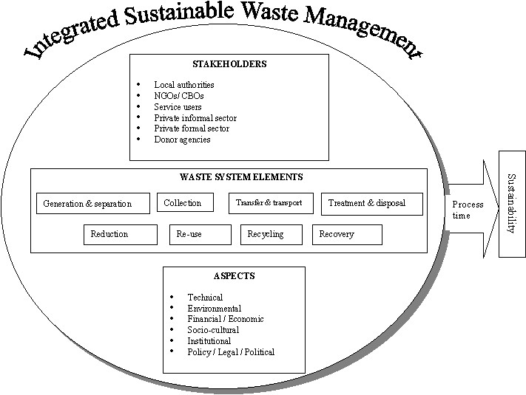

Figure 1. The ISWM Model

    - Financial/economic – pertain to budgeting and cost accounting within the waste management system and in relation to the local, regional, national and international economy. Some specific issues are: privatisation; cost recovery and cost reduction; the impact of environmental services on economic activities; the commodities marketplace; efficiency of municipal (ecological) sanitation management systems; macroeconomic dimensions of resource use and conservation; and income generation;

    - Socio-cultural – include the influence of culture on waste generation and management in the household; the community and its involvement in waste management; the relations between groups and communities, between people of various age, sex, ethnicity and the social conditions of waste workers;

    - Institutional and organisational – relate to the political and social structures which control and implement waste management: the distribution of functions and responsibilities; the organisational structures, procedures and methods implicated; the available institutional capacities; and the actors such as the private sector who could become involved. Planning is often considered the principal activity in relation with institutional and organisational aspects;

    - Policy/legal/political – address the boundary conditions in which the waste management system exists: setting goals and priorities; determination of roles and jurisdiction; the existing or planned legal and regulatory framework; and the basic decision-making processes).

Plenary Session Two: Current SWM Situation in Thimphu Municipality
Key points that emerged from this session were:

- By 2027 the population of Thimphu is anticipated to reach 162,000 (from 79,185 in 2005).

- The TCC Team responsible for the MSWM consists of 1 Environmental Division Chief, 1 Senior Environmental Officer, 2 MTO, 1 Labour Officer, 4 Sanitary Inspectors, 22 handyboys and 22 labourer workers.

- TCC spends Nu. 11 million annually on SWM of the city, which constitutes 18% of its annual budget and comes to an annual spending of Nu. 135 per resident. The recovery rate is Nu. 8 per capita or 6%, indicating that 94% of the total annual MSWM expenses are subsidised by the central government. 55% of the amount spent on SWM of the city is dedicated to waste collection alone.

51
65
81
103
131
0
20
40
60
80
100
120
140
2010
2015
2020
2025
2030
Ton waste/day

Figure 2. Waste Generation (ton/day) of Thimphu City

- The collection of the city‟s waste is carried out door-to-door with 8 compactor trucks and 2 tipper trucks, while the communal collection with 2 dumper placer carriers. The frequency is dependent on location. The collected waste is directly transported to the landfill, where upon its disposal some materials are recovered by informal waste pickers and sold to licensed scrap dealers, who in turn take the recyclables to the Indian border for resale. There are some instances of door-to-door collection of recyclables being carried out by waste pickers as well.

- The city‟s landfill, which was built in 1994 with a lifespan of 8 years at the time when the waste generated per day was 8 tons, is today overflowing as it currently receives 50 tons of waste a day.

- Studies of the city‟s waste composition reveal that 49% are organic wastes, 25.3% paper, 13.7% plastics, 3.6% glass, 3% textiles, 0.5% metals, 0.4% electronic waste and 4.5% others (per capita waste generation trend is shown in Figure 2).

- TCC is composting on a pilot-basis some of the organic waste. It also processes PET bottles, which are shredded into PET chips, packaged and exported abroad. Furthermore, low-grade paper is being produced locally from paper waste. A new paper recycling plant is soon to be established in Bjemina Industrial Estate, which will produce quality paper suitable for office use. The goal is to put in place a paper waste collection scheme covering the entire country. A local company called Greenerway is also collecting paper waste and exporting it abroad.

- Bhutan currently has the following legal provisions that regulate waste management activities:

  - Water and Sanitation Rules of 1994;
  - Solid Waste Management Rules and Regulations for Thimphu City of 2007;
  - Waste Prevention and Management Act of 2009; and
  - The formulation of a new Solid Waste Management Rules is expected to be completed by July 2010, which will facilitate the implementation of the Waste Prevention and Management Act

- Lack of a systematic waste collection scheme, illegal waste dumping, poor enforcement of rules and absence of a systematic enforcement mechanism, very low levels of community participation in waste prevention and management, the general perception that tackling of waste management problems is the responsibility of the TCC/Municipalities alone, limited manpower are amongst some of the main constraints preventing the effective management of MSW in Bhutan.

- TCC views PPP as a promising approach to involve private sector in MSWM, reduce the financial burden on the government, increase the efficiency of usage of resources and enable the city corporation to concentrate its efforts on other service areas.

- The PPP-ISWM project in Bhutan has as its goal the improvement of the natural environment and creation of employment opportunities through the establishment of an Integrated SWM system run under a PPP model. It is expected that the involvement of private partners and the informal sector through the PPP-ISWM approach will help achieving the desired levels of efficiency and effectiveness in the collection and disposal of MSW in Bhutan in an environmentally friendly way.

Plenary Session Three: PPP as an Approach for ISWM Services Delivery
Key points raised in this session were:

- In most of the countries around the world the primary responsibility and accountability for SWM services delivery rests with the State/Public Sector (national and/or local governments).

- That does not imply that the public sector must deliver the SWM services itself and alone. It rather suggests that the public sector has to guarantee and ensure adequate and equitable provision of SWM services to the entirety of its population.

- The public sector may itself deliver the complete range of SWM services together with the relevant infrastructure or may also involve the private sector and/or other NSAs through various contractual (PPP) arrangements into the delivery to the public of parts or the entire range of SWM services.

- UNDP-PPPSD – WASTE objective is to support through the PPP-ISWM initiative processes leading to the establishment of inclusive Pro-Poor PPPs that rally the strengths of all partners to address SWM services delivery challenges and thus contribute to the achievement of the MDGs.

- The ultimate goal of a PPP should be the effective, efficient and equitable delivery of the selected public service that it has set out to deliver, and not simply the infrastructure that enables the given service to be delivered.

- The NSA side in a PPP may differ depending on local circumstances and country interests and involve actors as different as large or small, formal or informal private businesses, NGOs, CBOs and even FBOs.

- The degree of NSAs‟ involvement may vary depending on local conditions and the needs and objectives of the public sector. It can range from 1 to 3 year-long engagement through a Service Contract, where the private company or the NSP performs specific tasks for the public sector on a contractual basis, to a much longer and greater delegation of the public service delivery function to a NSP via a 25 to 40 year-long Concession Contract, where the NSP pays fee to operate public assets and is expected to finance capital investments, or a 25 to 40 year-long Build-Operate-Transfer Contract, where the NSP develops, finances and operates facilities and once it has recovered its investment it transfers the function and assets back to the public sector.

- The name of the contract per se is not important. It is being able to adapt these contract principles to local conditions and needs and being clear about the eventual basic arrangements is the key.

- It is extremely important that right from the onset proper policy directives and regulatory regimes with clear poverty reduction objectives and incentives are put in place and relevant performance indicators are reflected in contracts with NSPs.

- Under Pro-Poor PPP arrangements commercial interests of partners are met in a way that it benefits broader consumers and the poor as:

  - Consumers – by extending services to poor communities;
  - Sub-contractors – by purposely training and allowing poor people to work for private companies as sub-contractors performing specific functions of the SWM service delivery; and
  - Service providers – by facilitating and capacitating poor communities, groups and individuals to form cooperatives or micro-small-medium enterprises and thus become themselves service providers.

- For Pro-Poor PPPs to work it requires concerted efforts on the part of all stakeholders involved in the process and at all levels of a government.

Group Work One: Developing a Model or Mock up PPP for ISWM for Thimphu Municipality
The group exercise had the objective to:

- Provide participants with a better appreciation of issues discussed during the preceding 3 sessions;
- Spark off innovative ideas and potential solutions for improving SWM services delivery in Thimphu Municipality through the application of the PPP-ISWM approach; and
- Identify possible other issues that are important for the successful implementation of the PPP-ISWM initiative in Bhutan.

With these objectives in mind, three groups were formed and tasked to develop a graphic illustration of how parts or all elements of the ISWM system could be delivered through the application of the PPP model in Thimphu Municipality, whilst ensuring that the proposed arrangements: (a) do benefit on a sustainable basis the poor communities of the city; and (b) have a mitigation strategy in case of failure of the proposed arrangement (for further details of the exercise, see Annex 3 of this report).

Day Two: 27 April 2010
Day two of the training started with plenary presentations of the group exercises carried out on the previous day, which were followed by a comprehensive overview of Nepal‟s experience with ProPoor PPPs in urban basic services delivery and a highlight of implications for change in policy and regulatory frameworks for successful implementation of Pro-Poor PPPs in SWM.

This was followed by plenary sessions and group work, in which further ISWM-related issues were introduced, such as compost marketing, recycling as a strategy for waste reduction, and financial and economic aspects.

Plenary Session One: Presentation of PPP for ISWM Models for Thimphu Municipality
The group exercise helped participants to better grasp issues related to PPP provision of ISWM services. All three groups came up with very pragmatic models that converged in many ways with one another (a model that is representative of the all 3 presented mock-ups is shown in figure 3).

In the main, the proposed PPP-ISWM models for Thimphu city suggested that:

- The ISWM elements or functions that in the first order could be delegated to private or nonstate providers are SW Collection, and SW Transfer and Transport (i.e., functions that take out 55% of the TCC‟s annual SWM budget);
- The preferred in the short run contractual arrangements for engaging NSAs into these functions would be Management Buyout and Leasing (of TCC‟s existing equipment and transfer stations). However, the preferred in the long run PPP options are Concession/Franchising;
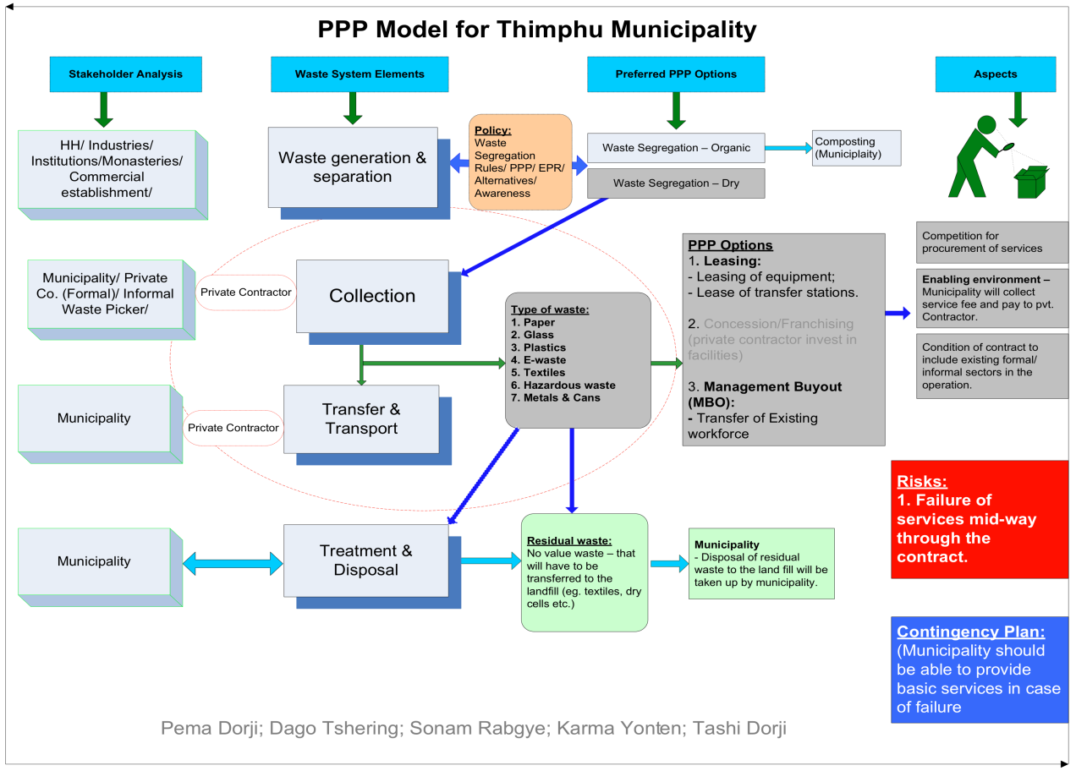

Figure 3. Group Work Output – a PPP-ISWM Model for Thimphu Municipality

- As Leasing and Management Buyout are typically fairly short-term contracts, ranging from 3 to 15 years in duration, they provide the necessary time for TCC to test out and firmly grasp the PPP approach so that it can enter into more complex partnership arrangements in the future, whilst for the Central Government to institute meanwhile the required PPP laws, rules and regulations;
- Moreover, these contracts would allow TCC to transfer its existing sizable workforce to the newly established “Management Buyout” company, whilst contributing to the development of the private sector in Bhutan;
- TCC would itself collect the service fees from the population and ensure payment to the private contractor for its service provision;
- In turn, the private contractor would be expected, inter alia, to find innovative ways of employing/integrating into its business operations the informal sector currently living out of waste recycling;
- TCC would retain the SW Treatment, the final Disposal of residual waste and the Landfill
Management functions; o In case of a service provision failure by the NSP, TCC should be in position/able to swiftly redeploy its equipment and manpower retained for SW Treatment, Disposal and Landfill Management for execution of SW Collection, Transfer and Transportation functions as well.

Plenary Session Two: Nepal’s experience with Pro-Poor PPPs in urban basic services delivery
Key points that emerged from this session were:

- The Nepal National PPPUE Programme has been working for over 7 years to increase the access of urban poor in Nepal to basic services by promoting and implementing Pro-Poor PPPs.

- Through activities such as awareness raising, policy guidance, tools development, capacity development, institution and partnership development, demonstration projects, the Nepal National PPPUE Programme has achieved thus far:

  - Minimum legislative arrangements are in place (including PPP Policy and Guidelines, PPP Committees, and PPP procurement provisions reflected in LSGR);
  - Confidence of the private sector gone up;
  - Increase in revenue generation for municipalities from various PPP initiatives; and
  - 64 PPP projects piloted, which created 500 direct jobs for youth, women and individuals from socially disadvantaged groups.

- The key lessons learned from Nepal PPPUE activities are:

  - Although a PPP is welcomed by all, the actual implementation is time consuming;
  - As investment-type projects take time to be developed and implemented, it is better to start with small operational-type projects;
  - An enabling environment is essential to ensure participation from the private sector;
  - Without Project Financing Policy private sector will not invest into large PPP projects;
  - The participation of the civil society is important for the success of PPP projects;
  - Special attention must be given to ensuring that PPP projects are Pro-Poor, otherwise, both municipal bodies and private operators may overlook this component;
  - Significant employment opportunities can be created through PPP projects for the poor and targeted groups within the community, contributing thus to local poverty reduction efforts; and
  - Capacity development of both municipal authorities and private sector at various levels is essential.

- Related specifically to PPPs in SWM, Nepal is another country which was selected to also pilot the PPP-ISWM initiative in Asia region. The PPP-ISWM project in Nepal sets out to facilitate the development of a sustainable, fee-based, service contract-type Pro-Poor PPP for collection, transfer and disposal of SW (including street cleaning) in Biratnagar SubMetropolitan area. Nepal PPPUE Programme‟s earlier intervention in Biratnagar led to drawing the following lessons, which it will be addressing through the new PPP-ISWM project.

Those are:
  - The earlier intervention focused more on streets cleaning and not sufficiently on revenue generation;
  - The only source of revenue generation was household fee charges, which are not adequate for the sustainability of the PPP;
  - Limited capacity on the part of the municipality to regulate and monitor the performance of the PPP;
  - Little collaboration with Tole Lane Organisations (i.e., CBOs), which were already carrying out small-scale waste management and composting activities;
  - The composting plant was established without proper raw materials supply and market studies.

- As the project progresses, Nepal will be pleased to further share its experience and lessons learned in PPPs for ISWM services delivery with Bhutan.

Plenary Session Three: Pro-Poor PPPs for ISWM – Policy Implications
This session had the objective to summarise midway through the issues examined during prior plenary sessions as well as the group work, in order to draw the participants‟ attention to what they actually mean for Bhutan in terms of possible changes in policy and regulatory frameworks to ensure successful Pro-Poor PPPs for ISWM services delivery. Key issue raised in this session were:

- It will be crucial to undertake through a concerted effort at all levels of the Government a system-wide review for conflicting policies, rules and regulations and streamline them for consistency;

- While doing so, to consider instituting policies and regulations that, inter alia:

  - Allow flexibility in adapting technical standards to reduce costs to serve poor neighbourhoods;
  - Allow services to be differentiated in order to satisfy user preferences;
  - Allow phased payments of service provision fees or daily collection of fees;
  - Address land tenure issues;
  - Ensure provision of direct, well targeted subsidies to the poor;
  - Allow small-scale providers to serve poor neighbourhoods or encourage on a preferential basis local and community-based businesses‟ involvement in the delivery of the service;
  - Promote and facilitate micro-credit for small-scale service providers;
  - Ensure that private contractors do not “cherry pick” only most attractive (wealthy) neighbourhoods for delivery of the service; and
  - Promote users forums, and adequate customer care and poor users‟ feedback mechanisms.

Plenary Session Four: Compost Marketing and Recycling as a Strategy for Waste Reduction
The sub-session on Compost Marketing had the objective to analyse and discuss issues related to marketing of compost, as many initiatives have failed due to the lack of proper marketing studies. Key points raised in this sub-session were:

- A good marketing strategy closely examines: the product (features, benefits, quality, packaging and presentation); the price (determined by production costs, willingness to buy of consumers); the place (accessibility of the product by customers, e.g. distribution network); and promotion (inform the benefits to your clients, e.g. quality level).

- It is important to link the business with the market, e.g. in India agricultural experts advise farmers on the use of compost, in Sri Lanka the business is managed by 3 actors (business, university and communities) and in the Netherlands the use of compost was the result of a directive which decreased the number of landfill sites, which led to municipalities look for options to decrease the disposal of organic materials contained in the solid waste.

- Communication tools to be used in the marketing of compost are: face-to-face information sharing or word of mouth, direct contact, training activities, advertising, sales promotion, publicity/sponsorships, exhibitions of organic products or soil conditioners, identity, and an attractive packaging.

- Bhutan has started on a pilot basis to explore opportunities for the production of compost. It will be important to analyse the quality of the compost and the opportunities for its use. Efforts have to be made to upscale the production of compost and connect it to the market.

- Agriculture is one of the main economic activities of the country and currently animal excreta-based manure is widely used at the household level. It will be important to provide training to households on “home composting” with the aim of enhancing the compost quality and demonstrating to farmers the short and long-term gains of the use of compost.

- Compost production helps reducing the organic waste that is sent to the disposal site and hence is a sound strategy for waste reduction.

Key points raised in the sub-session on Recycling as a Strategy for Waste Reduction were:

- Currently Bhutan does not have SW recycling plants or industry per se;

- However, some SW recycling activities are already taking place in the country in the form of recovery of recyclables by waste pickers, transporting of recyclables by local scrap dealers across the border to India for resale, and some processing and exporting of PET plastics;

- It will be crucial now to methodologically analyse the flow of SW materials (their types, quantities and destinations) and the stakeholders involved in this process in order to better organise this activity, make it more efficient and to determine opportunities for establishing Pro-Poor PPPs in SW recycling.

- Furthermore, organising the proper segregation of waste will be one of the most important factors for successful recovery of recyclable materials. It should start at the household level by the introduction of double separation (organic and inorganic) practices and be supported by adequate collection means such as door-to-door collection, drop off centres, and communal containers.

Group Work Two: Assessing the SW Recycling Situation in Thimphu Municipality using the ISWM Tool
The group exercise had the aim to:

- Provide participants with a better understanding of the SWM situation of Thimphu Municipality; and
- Identify possible stakeholders and areas whereto the PPP-ISWM approach can be applied to improve the overall SWM of the city.

The participants were divided into three groups and were tasked to: (a) list stakeholders that may be active in recycling activities in the city; and (b) identify problems and suggest possible solutions with regard to the waste management system elements and aspects in order to make the system sustainable and effective.

The Figure 4 shows the results for task (a).
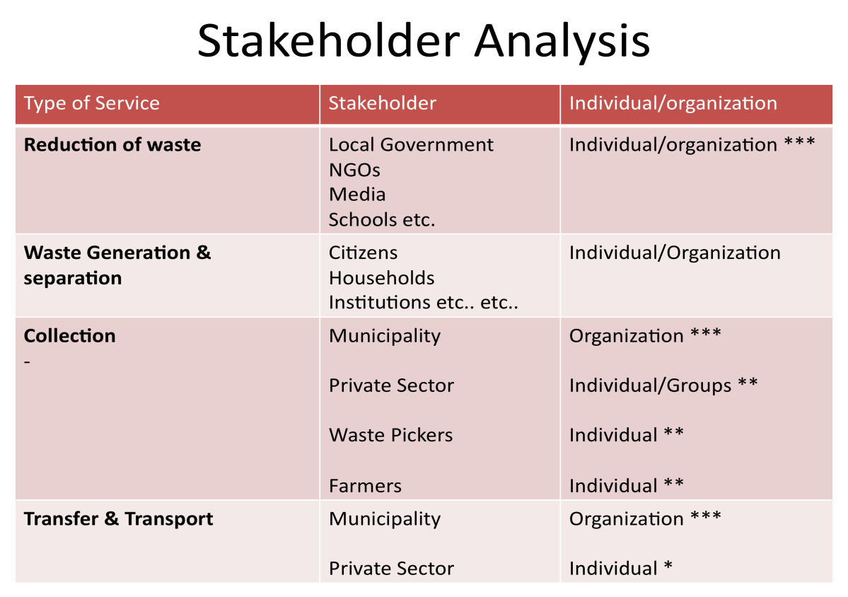

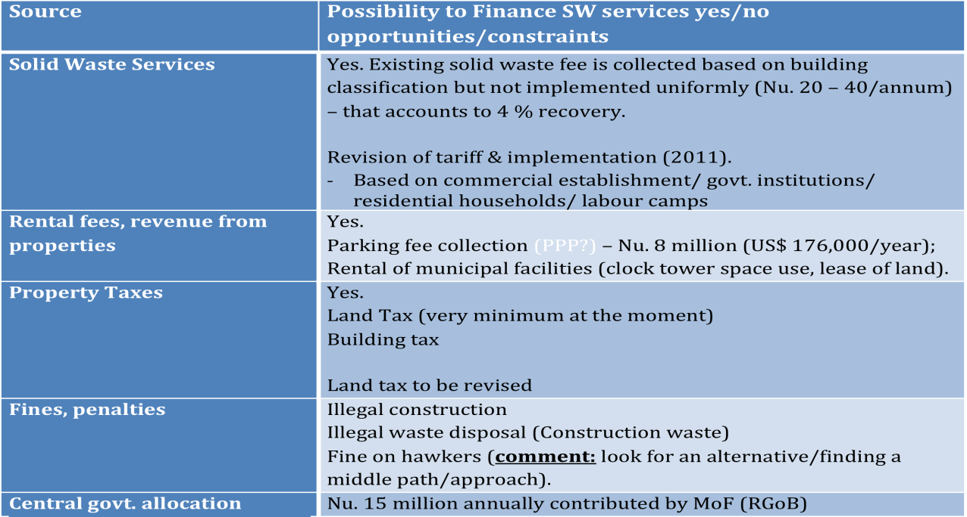
Figure 5. Group Work Output – Stakeholders Active in Recycling Activities in Thimphu City

As for the results of the task (b), the groups identified the following issues as the main problems with regards the various waste management system elements and aspects:

  - Shortages in manpower, vehicles, equipment and organisations involved in collection of recyclables;
  - Budget constraints to improve the collection of recyclable materials;
  - Lack of awareness on the Municipal Act, of an incentive system for recycling as well as of education on waste segregation at the household level; and
  - Capital investment is high, while the quantity of recyclable materials is low;

and suggested to consider trainings, awareness raising campaigns and proper equipment as possible solutions to address them.

Group Work Three: Financial and Economic Aspects of the MSWM System
Typically a high percentage of the municipal budget is used to fund waste management activities. Therefore, it is crucial to improve the budgeting and the cost accounting within the system and its relation to the local economy. As such, there two ways of achieving equilibrium for SWM operations, one is to reduce costs, and the other is to increase revenues.

This group work enabled participants to:

- Analyse various revenue streams (see Figure 6) that municipalities have and determine their relevance to TCC;
- While suggesting potential areas for cost reductions.

Municipality

Market, abattoirs,
business license fees

Fines,
Rental fees, revenues
from properties

Solid waste
services

Patents

Property
Revenues from

municipal enterprises

Central/state

government
allocation

External
borrowings

Revenues,
bonds

& credits

Donor financed
projects

Vehicle
Taxes:
hotels,

restaurants,

entertainme
Carbon financing, CDM,
VER

Figure 6. Potential Income Streams for Municipalities

Participants felt that some of the options, such as SWM services delivery charges, license fees and property taxes, were easier to introduce, while others, such as carbon financing, patents and bonds, were much more challenging to implement in the context of Bhutan.

The results of the exercise suggested that (see also Figure 7):

- Revenue increases can be achieved by means of raising various existing taxes and fees, making mandatory for businesses to pay waste removal and container rental fees, compost production and marketing, sales of recyclables, and processing and sale of some re-usable materials such as plastics;
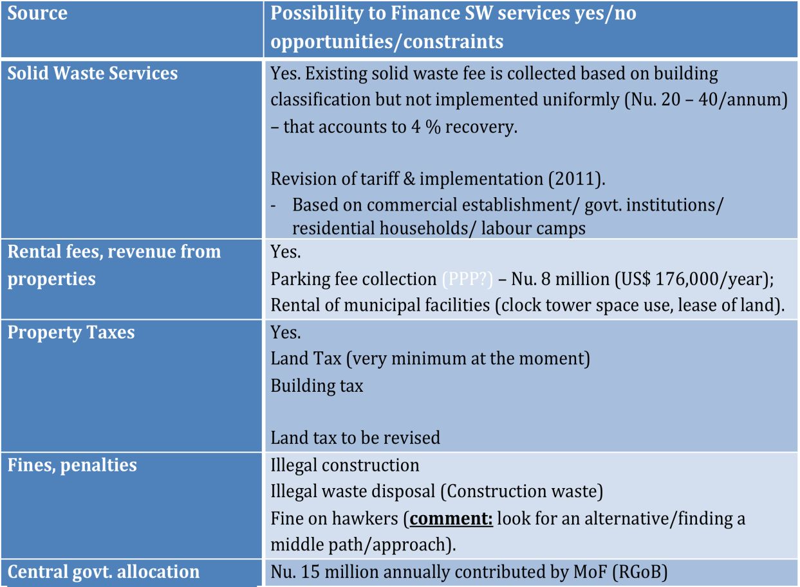
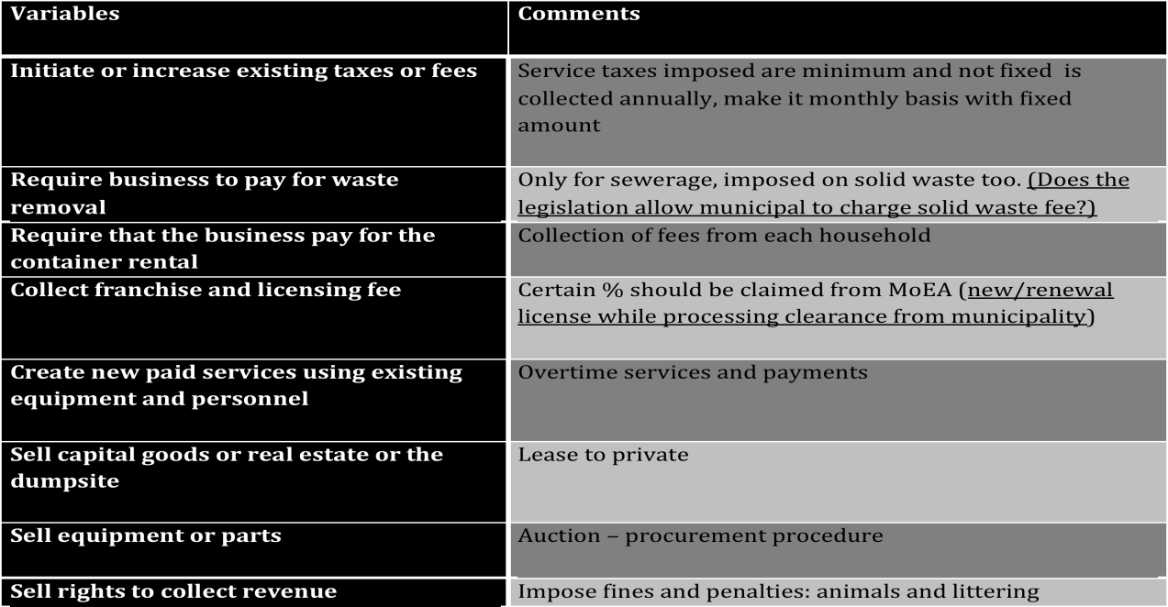
Figure 7. Group Work Output – Financial and Economic Analysis of the MSWM System

- Whilst cost reductions can be achieved through increases in efficiency of SWM operations by reducing the crew size and the frequency of waste collection, reducing the costs of maintenance of vehicles while increasing their lifespan by providing trainings to workers, requiring citizens to bring waste to specially assigned places, and establishing PPPs in different SMW functions.

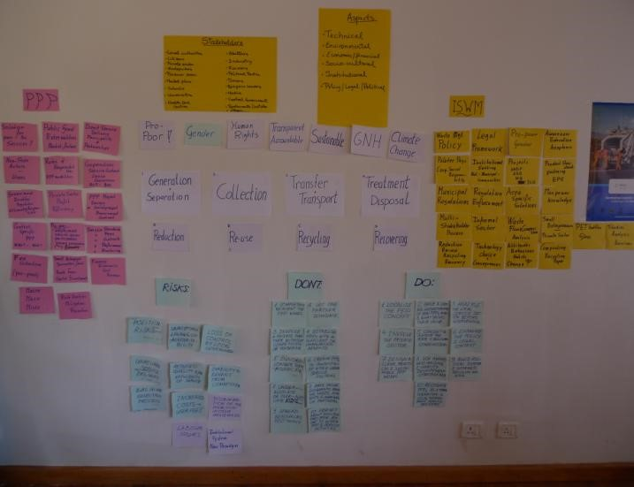
Day three of the training started with a recap of issues raised during the preceding two days by „building a wall-paper‟ that depicted the importance of Capacity Development processes, ISWM elements, issues related to PPPs and the design of a PPP-ISWM system (see Figure 8). The visualisation on the wall was thereafter used to present and discuss potential risks associated with PPP delivery of basic services (see Annexes 4 and 5), as well as the „Do‟ and „Do Not‟ tips for developing PPPs (see Annex 6) were highlighted.
Day Three: 28 April 2010

Figure 8. The PPP
-
ISWM Wall

Thus, the last day of the PPP-ISWM training consisted of a comprehensive overview of issues related to an initial formulation of a PPP-ISWM Capacity Development strategy for Thimphu Municipality based on the UNDP Capacity Assessment and Capacity Development approach, a group work and discussions around Gender Mainstreaming and Community Participation topics.

Plenary Session One: Capacity Development

UNDP defines CD as “process through which individuals, organisations and societies obtain, strengthen and maintain the capabilities to set and achieve their own development objectives over time”. It distinguishes different levels of capacity, based on a systems view, which mutually interact through complex co-dependency relationships (see Figure 9).

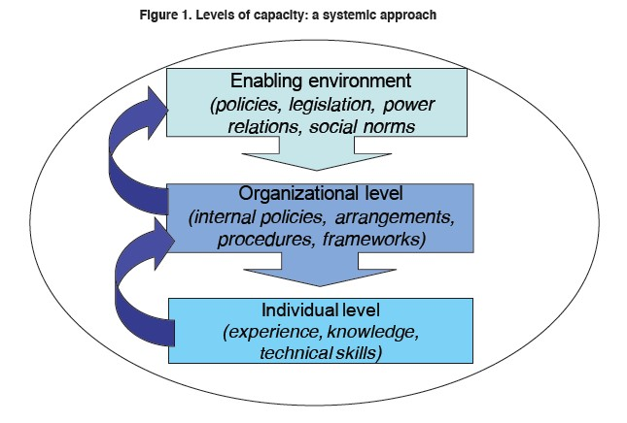
Figure 9. Levels of Capacity: a Systemic Approach

To enable better appreciation of various CD issues, an illustration of the institutional setting of Thimphu Municipality (see Figure 10) was provided. Based on it, upward and downward linkages with other stakeholders were identified, the need for horizontal coordination and collaboration for effective service delivery was discussed, and issues impacting the municipal services delivery at „enabling environment‟, „organisational‟ and „individual‟ levels were raised.

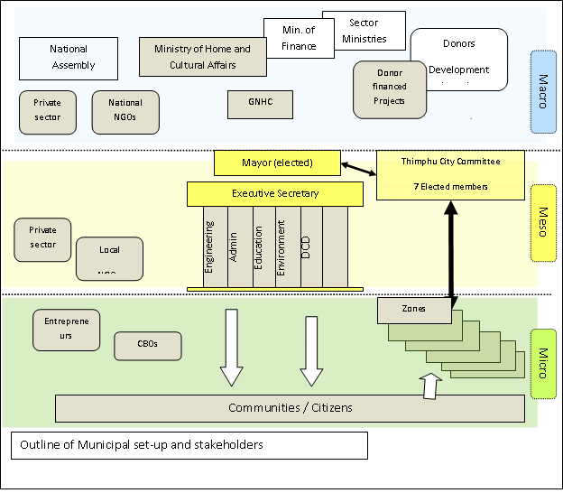
Figure 10. Institutional Setup of Thimphu Municipality

Key questions raised during this session were:

- Simultaneously developing the ISWM system and PPPs and integrating the two is challenging and requires a wide range of competencies. There is a need to have an appropriate number of staff assigned to the task and their capacities to be accordingly developed. The existing personnel are already overloaded by daily duties, which may delay the introduction and development of PPPs for ISWM.

- The PPP-ISWM Project Manager cannot carry out this task alone. Therefore, it is important to look at the conduciveness of the enabling environment and the participation of all stakeholders in this process.

- A better staffed project office within TCC for PPP-ISWM initiative implementation should be considered. Based on identified needs and realities, it can support the TCC in developing its capacity to ultimately develop and manage itself PPPs in SWM.

- It is crucial to keep people motivated and the motivation of each stakeholder is different. Strategising and developing short and long-term activities that deliver on some „quick wins‟ will motivate stakeholders to remain actively involved in the process. There is also a need to examine what can be influenced directly and internally and what could be stimulated from the outside with the support of external partners. The challenge, however, would be to have a clear direction and plan of action to achieve on the set objectives whilst allowing flexibility for accommodating wishes and concerns of all stakeholders.

- One of the main benefits of the PPP approach is that it provides the Municipality with the opportunity to use and deploy the capacities of NSAs for municipal services delivery, whilst the TCC is concentrating its efforts and resources on developing own capacities for creating an enabling environment, contracting and performance monitoring of NSPs. This, however, requires a whole range of different skills and competences, including legal expertise for formulating PPP contracts, monitoring and evaluation skils to develop performance indicators and a monitoring system, and financial analytical and accounting competences for developing and evaluating PPP proposals and monitoring their implementations.

- An issue closely related to CD is the need to look at the organisational capacity to effectively use the newly acquired knowledge by staff, to develop incentives to retain them and to institutionalise their knowledge. There are documentations available with global experiences on incentives to retain people in the organisation, which is helpful to understand what has worked in other countries. It is not always about financial incentives only.

- UNDP‟s core approach is to include CD processes in the design of all its programmes and projects. This is critical, as many of its programmes and projects in the past have failed due to the lack of a methodological approach to CD processes, including Capacity Assessments.

- In the Bhutan PPP-ISWM Project CA and CD processes are included right from the beginning, as the main tool for achieving on the project objectives. A methodological assessment of the existing capacity will reveal various capacity needs and facilitate the formulation of a more focused and systematic CD strategy to achieve the objectives of the PPP-ISWM project in Bhutan.

Group Work Four: Capacity Needs Assessment of Key Stakeholders
In this exercise, the participants were divided into four groups, each group assigned a key stakeholder in Thimpu‟s PPP-ISWM process (i.e., Thimphu Municipality; Private Sector; Civil Society Organisations; and Informal Sector), and tasked, based on the understanding of the CD approach, PPP issues and ISWM concept, to:

- Identify the capacities required in the short and the long run, and ✓ To suggest „how‟ these capacities could be developed.

„Thimphu Municipality‟ Group

The Group identified the:

Strengths & Existing Capacity, which are:

- Legal provisions on waste management
- Legal Officer
- Waste management service provider
- Adequate resources available (infrastructure, staff, machineries)
- General procurement documents
- Provision for TCC to provide service under PPP
- Access to principles of PPP, policy, acts, sample contract documents related to PPP from other countries
- City Committee Members (peoples representative) for decision making process

and Weaknesses, which are:

 | Lack of PPP concept in the Organisation
 | Lack of appropriate Policy, legal documents on PPP (national level)
 | Lack of procurement guidelines specific to PPP
 | Lack of Institutions imparting PPP concepts (PPP knowledge center)

and suggested as Short-term CD Strategy to:

- Orient selected group of people from TCC on PPP
- Adapt the principles of PPP from experiences of other countries
- Selection of appropriate PPP models
- Develop tendering documents, evaluation committee, selection of private partner
- Design a contract document on the PPP (negotiable or non-negotiable, contract duration)
- Design a tool to monitor the implementation of PPP

and as Long-term CD Strategy:

- National level awareness raising on PPP, on requirements of PPP policy, Act,
Procurement rules o Decision on appropriate government ministry to take the ownership of PPP related issues
- Develop capacity at various level on PPP for preparation of PPP documents, policy, legal documents, procurement rules etc.
- ISWM related capacities o Engage with other stakeholders
- Know-how embedding: university

„Private Sector‟ Group

The main findings of the group were:

- Private sector involvement is in principle possible in all ISWM system elements. However existing capacity for partnerships is very weak and there is a need for substantial CD inputs for all ISWM elements as well as PPP models.
- Current municipal staff involved in, for example, waste collection, needs to be integrated in the private contractor company in a fair and transparent way.
- Awareness campaigns are needed to stimulate interest of private sector for PPP in ISWM. At present awareness levels are very low.
- Specific areas for CD identified are: business management, training in specialised PPP (Finance & Management), networking, market analysis, resource mobilisation, access to finance, cost-benefit analysis, contract negotiations, awareness on policies/regulations, and policy lobbying.
- A diverse set of CD methods are proposed: training, study tours, curriculum development in education institutes, use existing staff as trainers, resource persons (consultants).

„Civil Society Organisations‟ Group

The CSO group looked mainly at possible areas where CSOs could be involved in the partnership. Identified are the areas of waste reduction and separation, policy intervention and creating awareness. CSOs can also be involved in capacitating other stakeholders. The leading role of CSO was as collaborator in service delivery and creating a conducive environment. They can be good networkers and engage with multiple actors to ensure a good design and implementation process of the PPP.

It was noted that CSOs can also perform a „watchdog‟ and „advocacy‟ roles, e.g., to ensure propoor approaches and to engage through their networks with communities and CBOs. It was also noted that “CSO” covers a wide variety of organisations, encompassing e.g. the media and education institutes. A proper analysis is therefore necessary to identify the variety of CSOs and their multiple roles in the PPP process.

„Informal Sector‟ Group:

The group identified as part of the informal sector waste pickers, the scrap dealers and others that are engaged in the SWM system but are not formally registered. The informal sector in many cases is doing the same as the private sector, but they are not as visible. The group recommended the following steps for engagement with the informal sector:

- Identify current situation (short-term):
  - Baseline survey (income status, disaggregated data (man & woman), identify potential for partnership, specific needs (capacity in ISWM));

- Develop a mechanism to bring the informal sector into the ISWM:
  - Create awareness, establish open discussion forums and feedback mechanisms;
  - Discuss possible roles and responsibilities of all stakeholders;
  - Engage in non-formal education to strengthen informal sector;

- Partnership building:
  - Design a consultative process amongst NSAs (sensitize on PPP opportunities);
  - Facilitate setting up groups, associations, and committees;
  - Facilitate developing by-laws/regulations (capacity development – awareness – trainings) in line with the Waste Prevention and Management Act;
  - Support registration of groups with local governments (District/TCC);
  - CD for Micro, Small, and Medium Enterprises development (business planning, financial management, marketing, etc.);
  - Support integration of small informal groups into larger organisations (e.g., private sector companies);

- Outcomes:
  - Part of the informal sector is formalised within the ISWM;
  - Remaining informal sector is known and is a stakeholder participating in the system;
  - Employment generation/job security, livelihood improvement and developmental impact in line with the Gross National Happiness principles of the country; • Capacity developed for groups and individuals; and • Better enabling environment.

The plenary session and group work on CD was concluded by participants identifying the following possible CD methods, which helped creating a greater understanding about the CD methodology; that it goes well beyond just providing trainings. Those are:

- Training;
- Team work;
- Exchange visits, study tours;
- Organisational networks, task-forces, discussion groups;
- Joint-research, (inter)national partnerships;
- Seminars, conferences, policy dialogue platforms;
- Internet: mail, virtual education, chats, group-exchanges;
- E-governance, e-government;
- Action-learning and learning from performance monitoring;
- Manuals, tools, templates, standards;
- Peer coaching, feedback, reflection;
- Building relationships and creating meaningful exchanges; and  Practicing compassion in action.

Plenary Session Two: Gender Mainstreaming and Community Participation
The sub-session on Gender Mainstreaming reminded the participants of the important role that, for example, women (can) play in the effectiveness of the SWM system: at household by segregating waste, as entrepreneurs delivering related services, and as effective community mobilisers.

The sub-session on Community Participation had the aim to introduce Public Participation (PPt) as a problem solving, decision making tool, which allows systematic engagement and mobilisation of the public towards a collective goal. Key points raised during this sub-session were:

- PPt is the main ingredient in successful programmes that require public buy-in, ownership, and roll-out activities. It is about respect for those impacted by collective decisions.

- The PPt strategy developed for 3 Asian cities, for instance, focused specifically on women (rural and urban), who are the most important “waste managers” at household level, children, that can be an interface between parents and the knowledge acquired at school, and NGOs, that can provide support because they share a common cause of protecting the environment.

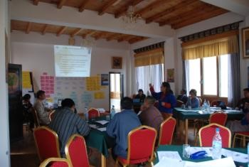

- The strategy encourages the responsibility and commitment also of major waste generators such as abattoirs, hotels, healthcare centres, petrol stations, restaurants, institutional, commercial and industrial sectors as well as sports and entertainment centres. It has a focal point in political and religious leaders.

CONCLUSIONS AND RECOMMENDATIONS

- The PPP-ISWM approach has a real potential for improving and further expanding the SWM services delivery of the TCC.

- However, due attention should be given to the complexities associated with simultaneous introduction of two new concepts as PPP and ISWM. Care needs to be taken in ensuring that both concepts are well understood, integrated and made complementary for enhancing the MSWM performance of Thimphu City and beyond.

- There is a need for enhancing staff capacity, in terms of time availability as well as competencies, to effectively run the PPP-ISWM project within the TCC. Success of the project also depends on the effectiveness of the collaboration amongst its key stakeholders. All key stakeholders therefore need to remain committed to the initiative throughout and their capacities need to be further strengthened to allow them to make substantive contributions towards its success.

- Different stakeholders have different roles and responsibilities in PPP and ISWM processes. Given that both concepts are new to Bhutan, capacities in these areas are likely to be weak, if not inexistent. Capacity assessments need to be carried out at the earliest possible juncture in order to determine the capacity needs of all key stakeholders and develop focused, stakeholder-specific CD strategies that the project shall pursue and address throughout its lifespan.

- The role of particularly SCOs in the success of Pro-Poor PPPs in ISWM services delivery is critical and cannot be emphasised enough. Given that the CSO Act has been passed most recently and the discussions about the possible role of CSOs in the country‟s development process is at a very early stage, likelihood of CSOs‟ capacity in Bhutan being very low is high. The CD strategy needs to take into account this context carefully.

- Currently the level of engagement of municipalities with their citizens or communities is acknowledged to be limited. Developing mechanisms and capacity to involve and to engage in dialogue with communities are equally important for the success of the PPP-ISWM initiative.

- The understanding of Capacity Development from a systems view needs to be further enhanced. Capacity Development is presently seen in Bhutan as mainly a training input at the individual level. Broadening the scope and understanding of Capacity Development thought its application to concrete issues as PPP delivery of MSWM services should be part of the Capacity Development strategy for PPP-ISWM initiative.

- It is important to understand that the Capacity Assessment and the Capacity Development strategy articulation processes will result in formulation of a plan of Capacity Development activities, which thereafter will need to be resourced and implemented. It needs to be ensured that political support is provided to create space for learning and developing capacities in PPPs and ISWM. Although some “quick wins” can be achieved though addressing certain types of capacity needs in order to stimulate the change process, Capacity Development remains a long-term venture and requires long-term political support as well as sustained commitment from all parties involved.

- Implementing only selected parts of the ISWM system, without a sound understanding of the overall system, should be avoided. The design of a single system element is highly dependent on other interconnected elements and on whether a PPP approach will be applied or not.

- There is a need for further training on the ISWM system and specific elements, such as composting, collection systems, engagement with communities/citizens and the informal sector.

- The participatory approach taken thus far to create a broad public awareness on opportunities and challenges related to PPP delivery of basic services has been very much appreciated by the stakeholders. This should be continued and expanded to include the informal sector and communities, until the imminent Capacity Assessment reveals the specific PPP Capacity Development needs of stakeholders. Once these available, more focused, structured and indepth PPP CD activities should be developed and conducted.

- The Work Plan of the PPP-ISWM project needs to be revisited and revised to reflect issues that have been brought to light during this PPP-ISWM Training programme, which this report has tried to capture and outline, including the need for a more detailed reflection of the Capacity Assessment and the Capacity Development strategy development process activities for the project.

ANNEXES

Annex 1: List of Participants

NAME | ORGANISATION
Batdelger Luuzan | Consultant
Dago Tshering | RSPN
Diana Brandes - van Dorresteijn | UNDP-PPPSD/Regional Centre Bangkok
Hendrik Visser | Consultant
Jamtsho Dukpa | City Corporation
Karma Yonten | Greener Way
Lilliana Abarca | WASTE
Lobzang | Wangdue District
Maki Mizumo Shaw | UNV-UNDP Bhutan
Myrtille Danse | Wageningen UR
Nabina Shrestha | UNDP Nepal
Pema Dorji | TCC
Phuntsho Wangyel | GNH Commission
SonamY. Rabgye | UNDP Bhutan
Tashi Dorji | UNDP Bhutan
Tshering Yangchen | TCC
Tshewang Dargay | Y –VIA- YDF
Tshultrim Dorji | Thim Throm
Ugyen Pem | TCC

Annex 2: Useful Resource Materials Supplied to Participants
Cambodia-related:
- “Law on Concessions, 2007”, Kingdom of Cambodia;
- “PPP in Infrastructure Development in Cambodia”, presentation by the Royal Government of Cambodia;
- “Anukret (Sub-Decree) on SWM, 1999” by Royal Government of Cambodia;
- “A System Dynamic Approach for Financial Planning in SWM: a Case Study in Phnom Penh City” by Veasna Kum, Alice Sharp & Napat Harnpornchai, 2004.

India-related:
- “PPPs – Creating an Enabling Environment for State Projects” by PPP Cell/Department of Economic Affairs/Ministry of Finance of India, 2008;
- “The Municipal Solid Wastes (Management & Handling) Rules, 1999”, Notification by the Ministry of Environment & Forests of India;
- “National Environment Policy 2006” formulated by the Ministry of Environment & Forests of India;
- “Financing SWM: Issues & Options” by Paul P. Appasamy & Prakash Nelliyat, 2007.

Philippines-related:
- “An Act Authorising the Financing, Construction, Operation & Maintenance of Infrastructure Projects by the Private Sector, & for Other Purposes, 1990” Republic of the Philippines;
- “An Act Amending Certain Sections of the Republic Act Nr. 6957, entitled “An Act Authorizing the Financing, Construction, Operation & Maintenance of Infrastructure Projects by the Private Sector, & for Other Purposes, 1990” Republic of the Philippines, 1994;
- “The Philippine BOT Center: Evolving PPP Agenda for Philippine Infrastructure & Development Sectors” by Eleazar E. Ricote, 2008;
- “Locking Private Sector Participation into Infrastructure Development in the Philippines” by Noel Eli B. Kintanar, Ma. Lourdes S. Baclagon, Rodolfo T. Azanza, Jr., & Rina P. Alzate, 2003;
- “Evaluation of Procurement Systems for BOT Infrastructure Projects in Asian Countries” by Kazumasa Ozawa, 2008;
- “Ecological SWM Act of 2000” Republic of the Philippines;
- “Guidelines on the Categorized Final Disposal Facilities (Sanitary Landfills)”, 2006
Administrative Order by the Department of Environment & Natural Resources, Republic of the Philippines;
- “Handbook on the Ecological SWM Act of 2000 & its Implementing Rules & Regulations” by Department of Environment & Natural Resources of the Philippines, 2003;
- in the compiled 3 papers on SWM-related issues, the one titled: “Ecological SWM Act of 2000
(RA 9003) – a Major Step to Better SWM in the Philippines” by Grace P. Sapuay; • “Implementation & Financing of SWM in the Philippines” by Zenaida M. Sumalde, 2004.

SWM-related:
- “Solid Waste Management” Volume I, UNEP, 2005;
- “Solid Waste Management” Volume II, UNEP, 2005;
- Chapter XV. Regulatory & Economic Instruments for SWM, pp. 439-446, “Solid Waste Management” Volume I, UNEP, 2005;
- “Conceptual Framework for Municipal SWM in Low-Income Countries” by Peter Schübeler, Karl Wehrle & Jürg Christen, 1996;
- WASTE Advisers on Urban Environment & Development Website: www.waste.nl
on the state of SWM in several Asian countries:
- “Municipal SWM in Asia – a Comparative Analysis” by C. Visvanathan & J. Trankler, 2003;
- “Urban SWM in Low-Income Countries of Asia – Hope to Cope with the Garbage Crisis” by Christian Zurbrügg, 2003;
- “SWM in Least Developed Asian Countries – a Comparative Analysis” by Ulrich Glawe, C. Visvanathan & M. Alamgir, ;
- compilation of 3 papers on SWM-related issues: “Development of Regional SWM Strategy in Indonesia – Case Study of Greater Bandung Area” by Eka J. Sundana, “Current Practices & Instruments Used in SWM in Vientiane, Lao PDR” by Bhoj R. Khanal & Bounsouk Souksavath, & “Ecological SWM Act of 2000 (RA 9003) – a Major Step to Better SWM in the Philippines” by Grace P. Sapuay.

on Financing aspects of SWM:
- Chapter XVI. Financial Arrangements for SWM, pp. 447-459, “Solid Waste Management” Volume I, UNEP, 2005;
- “A System Dynamic Approach for Financial Planning in SWM: a Case Study in Phnom Penh
City” by Veasna Kum, Alice Sharp & Napat Harnpornchai, 2004;
- “Financing SWM: Issues & Options” by Paul P. Appasamy & Prakash Nelliyat, 2007.

Composting-related:
- “Decentralised Composting for Cities of Low- & Middle-Income Countries – a Users‟ Manual” by Silke Rothenberger, Christian Zurbrügg, Iftekhar Enayetullah & A. H. Md. Maqsood Sinha, 2006;
- “Marketing Compost: a Guide for Compost Producers in Low- & Middle-Income Countries” by Jonathan Rouse, Silke Rothenberger, Christian Zurbrügg, 2008;
- “Closing the Circle: Bringing Integrated Sustainable Waste Management Home” by Anne Scheinber, Jeroen Ijgosse, Frits Fransen & Valentin Post, 2008.

Useful SWM-related Tools:
- “Tool for Calculating Greenhouse Gases (GHG) in SWM” – GHG Calculator – Excel Sheets developed by IFEU – Institut für Energie – und Umweltforschung Heidelberg GmbH, 2009;
- “Tool for Calculating Greenhouse Gases (GHG) in SWM” – Manual for SWM-GHG Calculator by Jürgen Giegrich & Regine Vogt, 2009.

PPP-related:
- “Report on the Public Consultation on the Green Paper on PPPs & Community Law on Public Contracts & Concessions”, Staff Working Paper of the Commission of the European Communities, 2005;
- “PPP in Europe: an Overview” by Freshfields Bruckhaus Deringer, 2005
- “Contractualisation: a Key to the Sustainable Management of Essential Services” by the Institute de la Gestion Deleguee, France, 2008;
- “Green PPPs – a Guidance Note on How to Include Environmental Considerations within PPPs & PFI Projects”, UK Government, 2002;
- “Evaluation of Procurement Systems for BOT Infrastructure Projects in Asian Countries” by Kazumasa Ozawa, 2008.

on Pro-Poor PPPs:
- “Tools for Pro-Poor Municipal PPPs”, UNDP, 2005;
- “Global Lessons Learned in PPPUE Local Level Initiatives in Support of Pro-Poor Partnerships for Basic Urban Service Provision”, UNDP, 2004;
- “PPPs for the Urban Environment: Starting a Pro-Poor PPP for a Basic Urban Service”, UNDP, 2005.
- “The White Paper on Municipal Service Partnerships” by the Department of Provincial & Local Government of South Africa, 2004;
- “Partnering for Development: Government-Private Sector Cooperation in Service Provision” by Dennis A. Rondinelli, ;
- “UNDP/PPPUE Paper – PPP in Urban Infrastructure Services” by P. Gidman, I. Blore, J.
Lorentzer, & P. Schuttenbelt, ;
- “Focusing Partnerships: a Sourcebook for Municipal Capacity Building in PPPs” by Janelle Plummer, 2001;
- “The Partnering Tool Book” by Ros Tennyson, the International Business Leaders Forum (IBLF), 2003.

PPP Legislative Provisions samples:
• “Model Legislative Provisions on Privately Financed Infrastructure Projects” prepared by the United Nations Commission on International Trade Law (UNCITRAL), 2004.

PPP contract samples:
- Sample Standard PPP Contract (for Leasing of Municipal Infrastructure or Facility);
- Sample Standard PPP Contract (for Service Provision Agreements);
- an Effective Concession Contract for the Piped Water Supply System of Houay Khoun &
Somseun Villages of Bolikhamxay Province, Lao PDR

Annex 3: Group Exercise: a PPP-ISWM Model for Thimphu Municipality

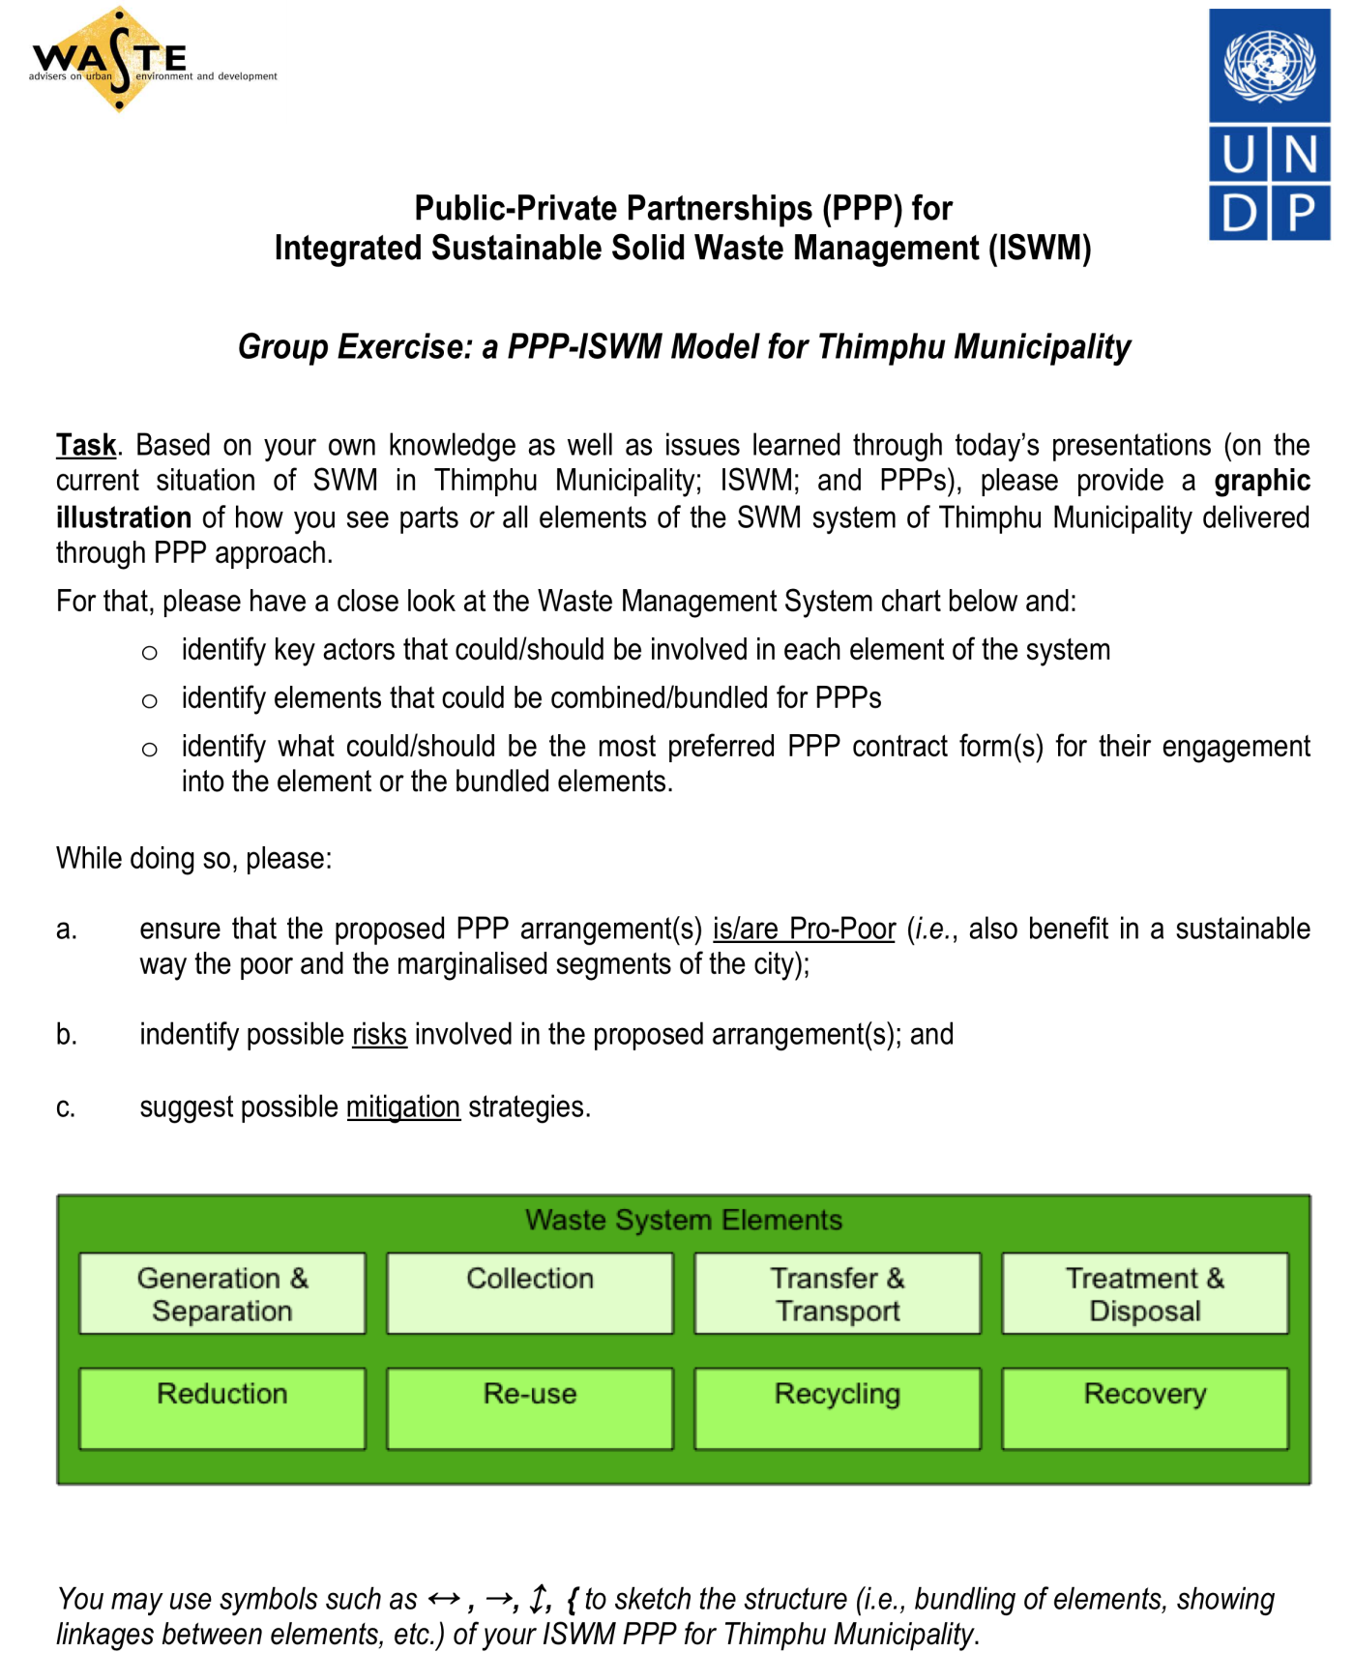

Annex 4: Some Risks Related to PPP Delivery of Basic Services

- Political Risks

- Unacceptable Levels of Accountability

- Loss of Control Over the PPP by Local Authorities

- Bias in the NSA Selection Process

- Unreliable Delivery of the Service

- Reduced Quality or Efficiency in the Service Provision

- Inability to Benefit from Competition

- Increased Costs, hence of User Fees for Consumers

- Discrimination against Poor/Low-Income Households

- Labour Dissatisfaction/Strikes related Issues

Annex 5: Risk Factors Associated with Various PPP Arrangements
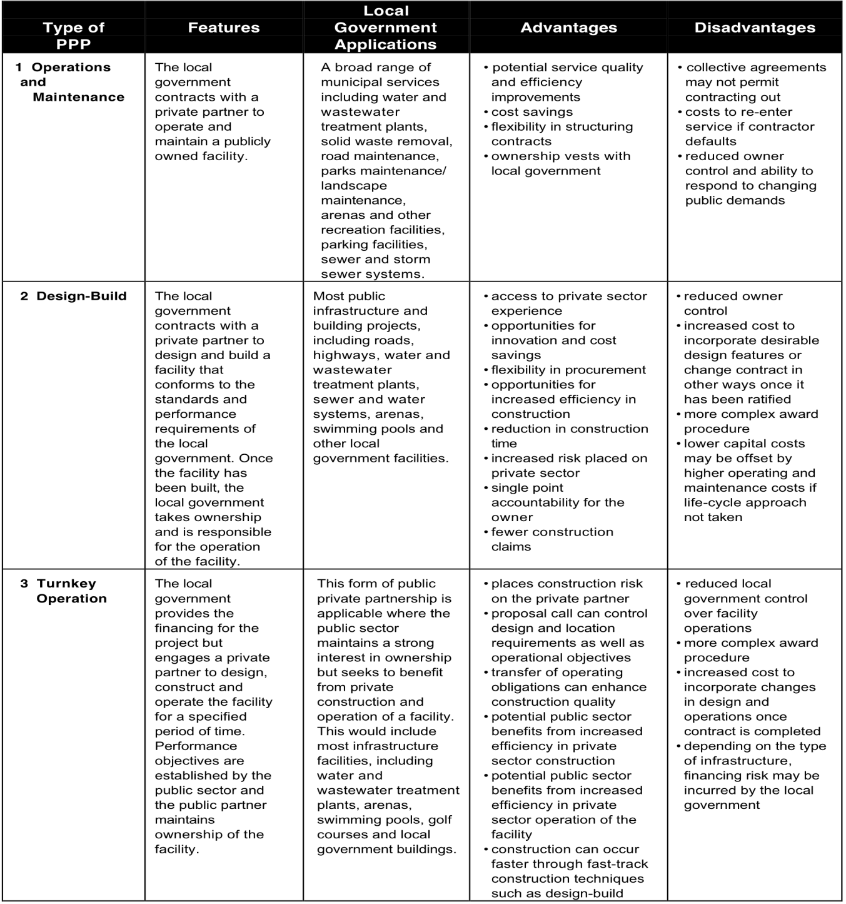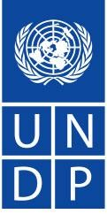

Public
-
Private Partnerships (PPP) for

Integrated Sustainable Solid Waste Management (ISWM)

Risk Factors Associated with V
arious PPP Arrangements

Source: “PPP: a Guide for Local Government”, Ministry of Municipal Affairs, British Columbia, Canada, 1999
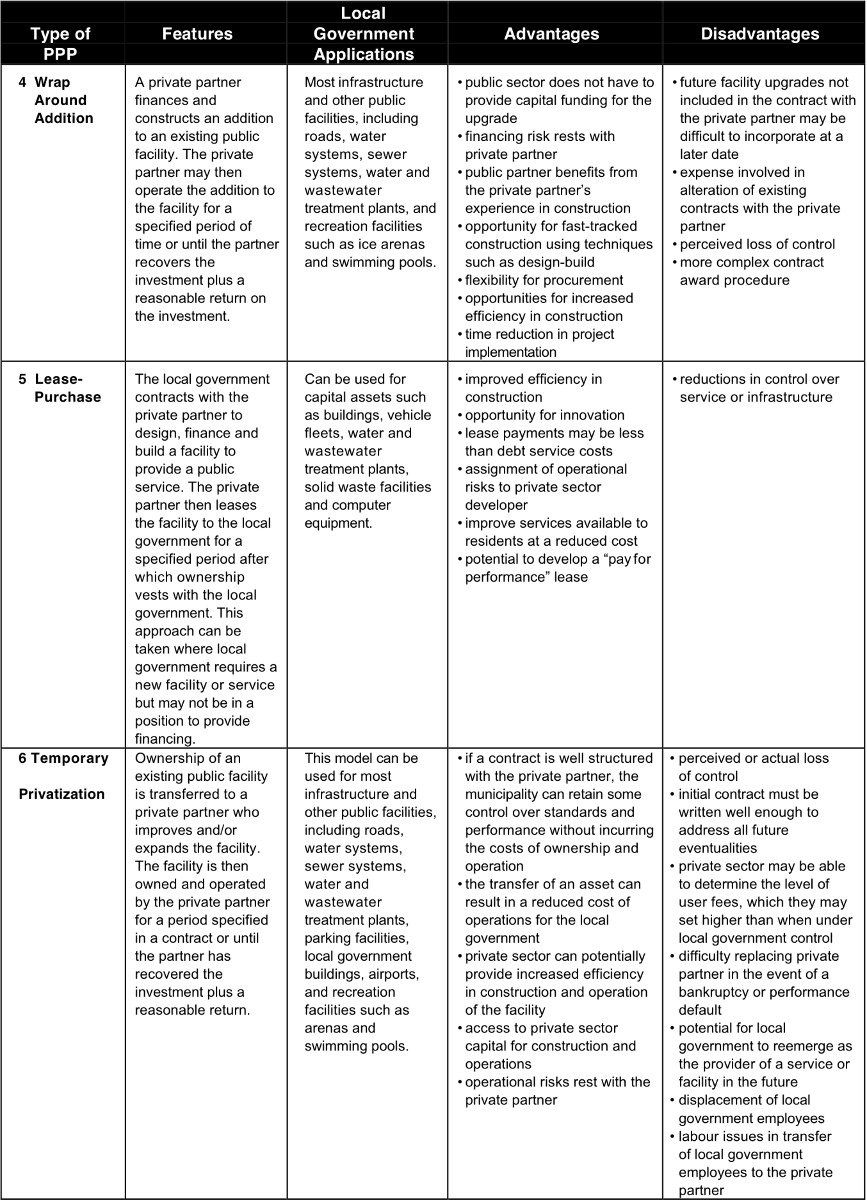
Source: “PPP: a Guide for Local Government”, Ministry of Municipal Affairs, British Columbia, Canada, 1999
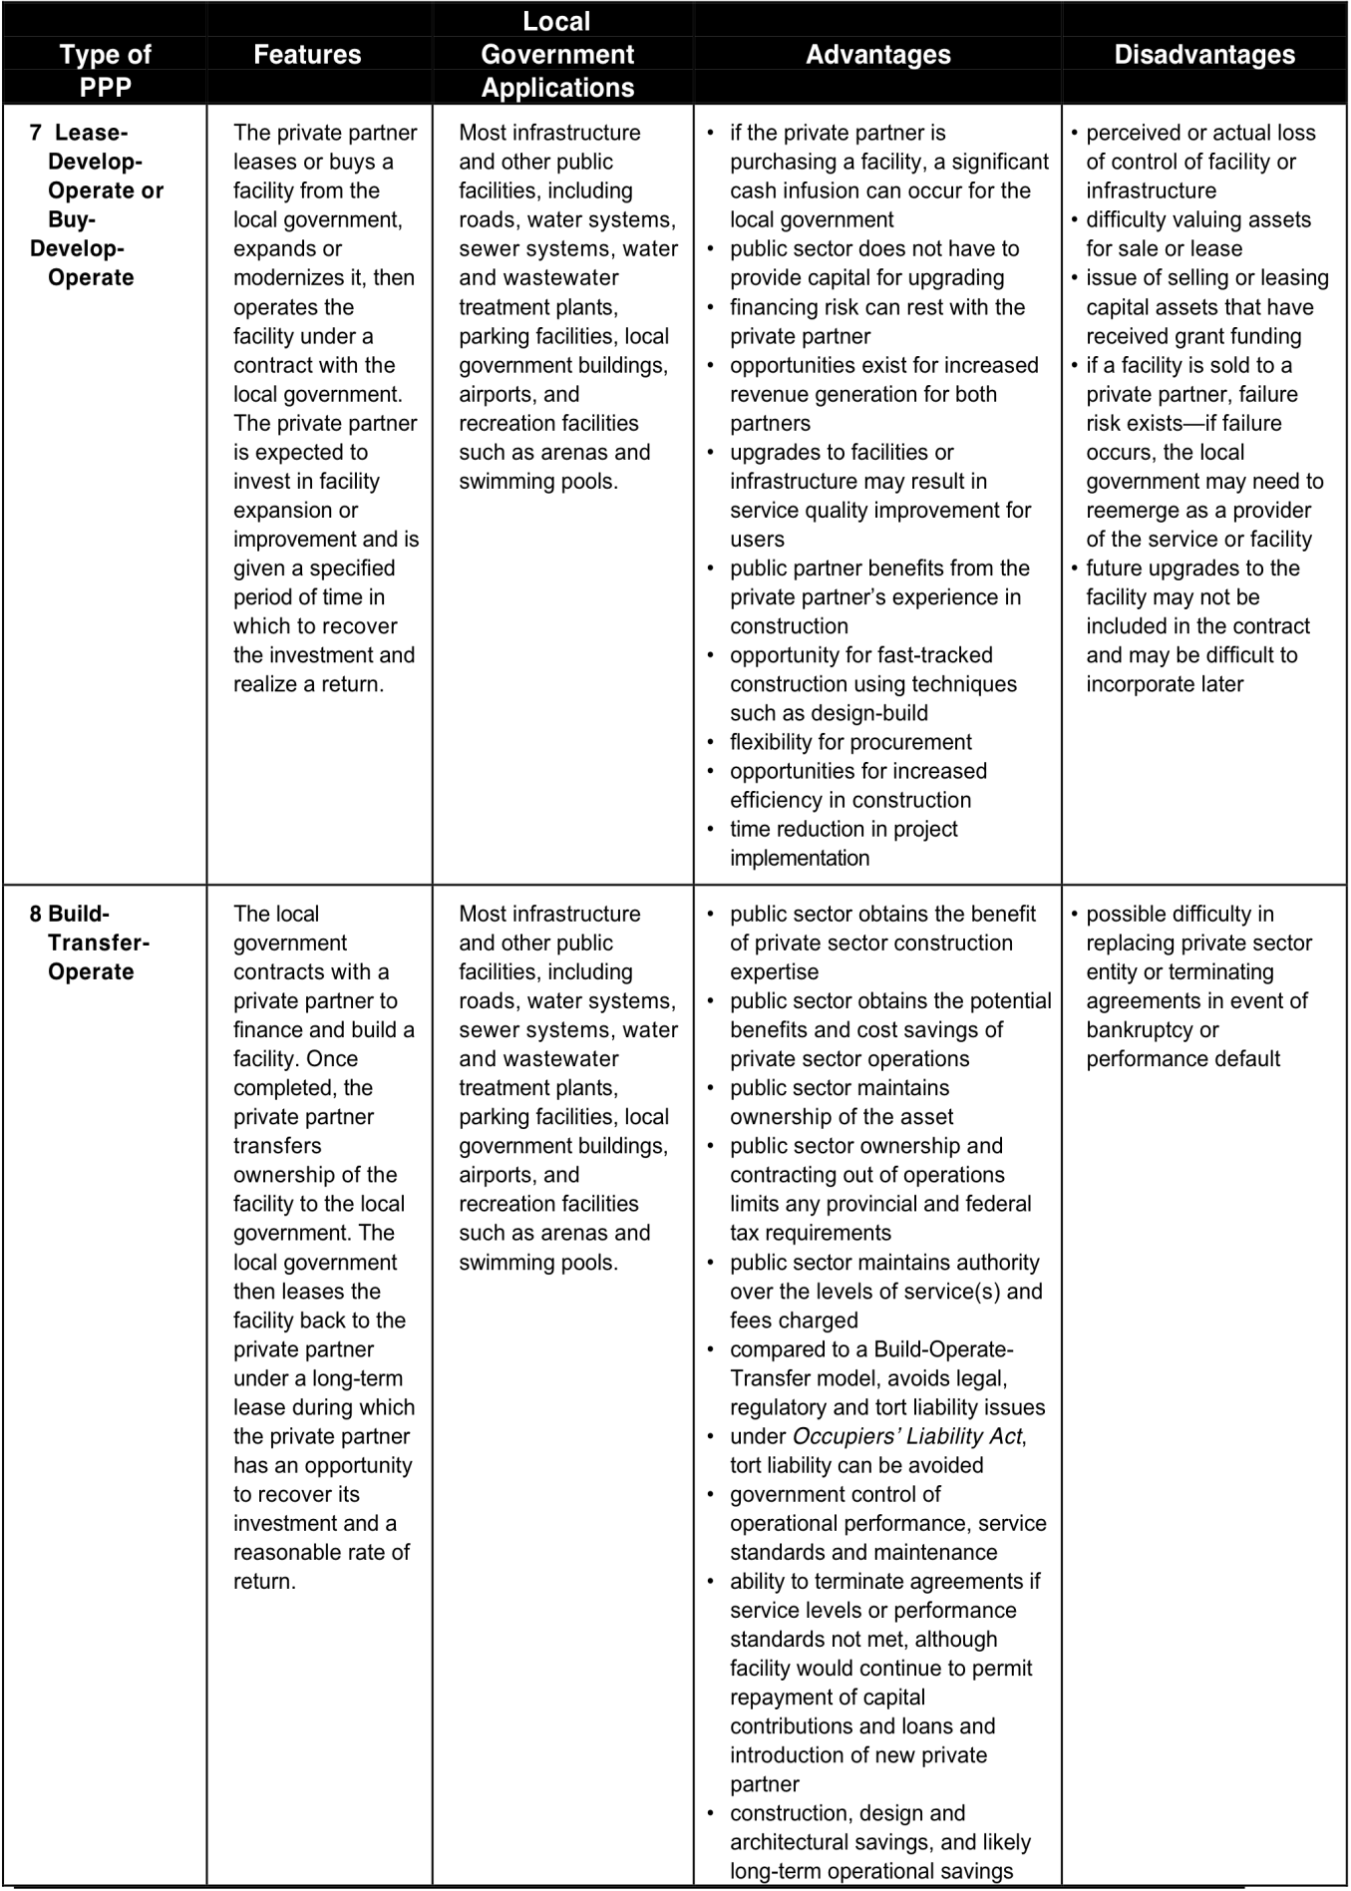
Source: “PPP: a Guide for Local Government”, Ministry of Municipal Affairs, British Columbia, Canada, 1999
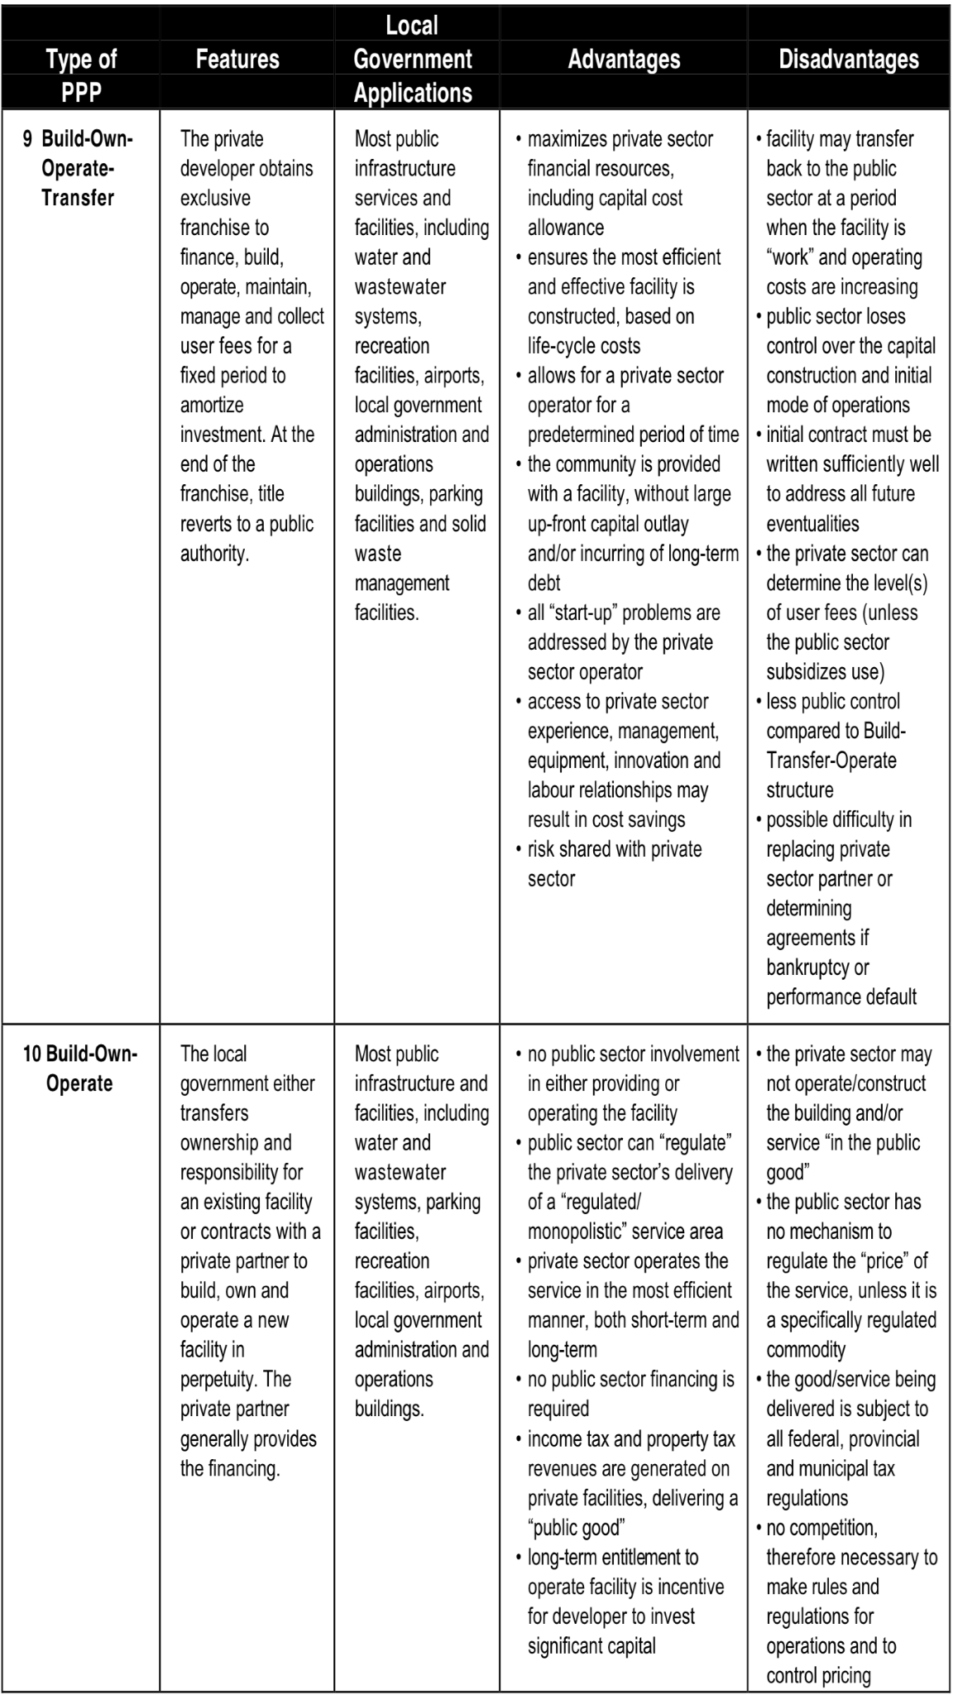
Source: “PPP: a Guide for Local Government”, Ministry of Municipal Affairs, British Columbia, Canada, 1999

Annex 6: The 10 “DO‟S and DON‟TS” of Pro-Poor PPPs

“Do‟s” for Pro-Poor PPPs

- Localise the PPP concept

Translate the concept into terms and names that will be understood locally. Look for local comparable arrangements, which will help people to understand. Sensitise the concept with local social, cultural, political and other realities.

- Have a strong understanding of how PPPs work and what drives their value

Build a strong understanding of PPP structuring, risk allocation, regulation, use of market mechanisms and competition and so on.

- Analyse the local service industry before intervening

Study the relevant service industry locally to assess how it is structured, who the main players are, how it operates, the financial flows and so on. A PPP should be designed only against the background of this knowledge.

- Involve the private sector

The private sector can be formal or informal, large-scale or small-scale, or even individuals from communities. But the „private‟ partner should be motivated in the correct way to respond to the partnership structure and hence to bring value for the urban poor. Use a two-stage approach: initial consultation with business associations, subsequently tendering for selecting the private partner.

- Consult and involve the poor and relevant stakeholders

Make sure the PPP will address priority services for the urban poor and that they will potentially benefit. Involve them and raise their awareness so they can play an appropriate role in the PPP.

- Examine the policy and legal context

Assess where possible policy or legal support or constraints exist. In some cases revision of existing or introduction of new policies and/or laws may be required before a pro-poor PPP can be implemented.

- Design a clear, practical and sustainable PPP model

Design the PPP so it fits within the wider service industry, financial flows and so on. Clearly outline roles, responsibilities, operational structure, financial arrangements, and other relevant structural components. Have this as a clear „picture‟ for which to aim.

- Use awareness-raising and capacity development strategically
Make sure relevant participants share the same fundamental understanding of how PPPs work. Make sure awareness-raising is oriented to achieve a clear output. Make sure all relevant partners receive the right kind of capacity related to the roles they must play.

- Build political support and informed decision-making

General political support is required for a PPP to proceed. Politicians and those in political office must understand the implications of undertaking a PPP and reach decisions in an informed manner. It may be necessary to establish purpose specific decision-making bodies.

- Recognise PPPs as a transformation in local government service delivery

The PPP approach should not be a once-off project or stand-alone pilot. PPPs are an alternative way for local governments to deliver services that can have benefits especially for the urban poor.

“Don‟ts” for Pro-Poor PPPs

- Completely reinvent the PPP wheel

While important to localise the concept, considerable expertise on PPPs is available and should be accessed. Look for demonstrations of what has worked elsewhere.

- Let one partner dominate

Whether it is the private sector, or government or the facilitating agency, where one partner is too dominant PPPs seem to fail.

- Involve a private partner without competition or tendering

PPPs create value by allocating risks and incentives and stimulating innovation from the private sector. Market competition and tendering is integral to reaching this value.

- Establish PPPs with insufficient or unbalanced benefits

Where partners do not benefit sufficiently, or where benefits are too unbalanced, the partnership will not be sustainable.

- Ignore longer term financing

To be sustainable PPPs should have clear financial flows, and should be able to access financing that may be required.

- Create PPPs in isolation of wider urban service systems

PPPs set up as once-off or stand-alone projects that are not related in relevant ways to the wider system of urban services do not seem to be sustainable. Rather the PPP should „fit‟ into wider operational and financial flows.

- Under-allocate or over-allocate risks

Where insufficient risk is transferred to the private partner (e.g., where government pays for everything) the PPP is not better value for the urban poor. Where too much risk is transferred to the private partner (e.g., where they must finance everything and carry too much of the responsibilities) the PPP is unlikely to work. The right balance of risk allocation must be achieved. This balance changes as the PPP market develops.

- Make value judgments about the needs, interests and motives of partners

Partners in PPPs have different needs, interests and motives that are not the same for all partners.
It is unrealistic to expect all partners to think in the same way about the urban poor. For pro-poor PPPs to work, the differing needs, interests and motives of partners must be acknowledged and taken into account.

- Spread resources too thinly

In most situations demand for better services far outstrips the resources available. Geographically and sectorally focusing initial PPP efforts can get pro-poor PPPs working that can serve as demonstrations and models for dissemination to others places and kinds of services.

- Forget about possible pro-poor „add-ons‟ to wider PPP and service activities

Adding pro-poor approaches and considerations to other, bigger service PPPs can significantly benefit the urban poor. Similarly, broader urban service reforms and improvements can be made more pro-poor oriented.

Annex 7: South-South Cooperation in Action: An Exchange of PPP Experiences in Nepal and Bhutan

waste on the environment and human health.  Implementing partner organisations in Thimphu, with support from UNDP Bhutan and the Asia regional UNDP PPPSD team, | Tashi Dorji, Programme Officer, UNDP Bhutan (left), and Nabina Shrestha, Private Sector Analyst, UNDP Nepal  (right).
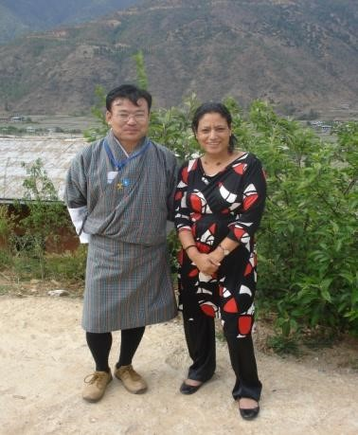
Ms. Nabina Shrestha, of Kathmandu, Nepal, recently traveled to Bhutan to share experiences, lessons, and best practices from the Public-Private Partnerships for the Urban Environment (PPPUE) program in Nepal with counterparts in Bhutan.
In Bhutan, Thimphu Municipality is implementing a project on Integrated Sustainable Waste Management (ISWM) through an approach of Public Private Partnerships for Services Delivery (PPPSD). The project aims to improve delivery of municipal solid waste management services, while at the same time creating employment opportunities and mitigating the negative impacts of
organized a training in April 2010 to introduce approaches to
Integrated Sustainable Waste Management (ISWM) using Public Private Partnerships (PPP) as a modality for planning and implementation. As part of UNDP‟s global PPPSD-ISWM initiative, the Bhutan training also involved collaboration with WASTE, (a Dutch NGO and a civil society organization that functions as a knowledge institution).
A key component of this recent PPPSD-ISWM training, however, was the opportunity for partners in Bhutan to benefit and learn from Nepal‟s experiences in this area. Ms. Shrestha explained how Nepal‟s Public Private Partnerships for Urban Environment (PPPUE) project, initiated in 2002, has been implemented by the Ministry of Local Development (MLD) with financial support from UNDP and ADB in 13 municipalities. The project has focused on policy support, capacity development and the design of pilot projects. In recent years, “PPPUE” has been absorbed under the broader “PPPSD” as part of a renewed commitment to achieving the MDGs at the local level. The programme in Nepal facilitates PPP processes by focusing on projects that support poverty reduction through the promotion of active involvement of civil society in planning and implementation, with a view to ensuring that these initiatives benefit youth, women and socially excluded groups. The projects in Nepal have been successful in creating jobs, improving access to services, and promoting environmental protection in the sectors of solid waste management, water and sanitation.
Reflecting on Ms. Shrestha‟s contributions to the training, Mr. Pema Dorji, National Programme Manager of Thimphu Municipality noted, “PPP is a relatively new concept in Bhutan, and the sharing of Nepal was therefore found to be timely and very informative”. The Municipality thought to apply the PPP modality mainly in the waste management sector, but after the presentation(s) and informal discussions we feel that PPP should be applied to many other sectors too”. Mr. Tashi Dorji, of UNDP Bhutan, similarly stated, “The socio-cultural situation of both countries is quite similar so the sharing of experiences was found very useful for the participants”.
Nepal has significant experience with pro-poor PPPs for service delivery and the lessons documented will help Bhutan to formulate PPP approaches for ISWM and other service delivery sectors. A number of follow up activities such as sharing of policies, rules and regulations, contract papers, and good practices on community mobilization and gender engagement and organizing an exchange visit to Nepal were agreed upon. Through this practical sharing and exchange, the collaboration between countries was further strengthened.

UNDP through PPPSD provides technical and advisory services for the creation of an enabling governance environment with appropriate legal, institutional, financial and regulatory framework and supporting capacity development of the stakeholders.

For more information, please visit: http://www.undp.org/pppsd/index.html

25 May 2010 Exchange Rate: BTN or Nu. 47 = USD 1

